Sarvajanik Education Society



## Shree Ramkrishna Institute of Computer Education and Applied Sciences

Behind P.T Science College, M.T.B. College Campus, Athwalines, Surat-395 001.

# A Software Project On

**Canteen Automation System**

*as the partial fulfillment of*

**Semester -V study**

*for the degree of*

**Bachelor of Science (Computer Science)**

*(Affiliated to Veer Narmad South Gujarat University) during the academic year 2019-2020.*

## Developed By: Guided By:

### 1) Ishika Pawar Mrs.Shweta Bhatia

**Sarvajanik Education Society**

**Shree Ramkrishna Institute of Computer Education and Applied Sciences**

**Behind P.T. Science College, M.T.B College Campus, Athwalines, Surat-395 001.**

CERTIFICATE

**DEPARTMENT OF COMPUTER SCIENCE**

This is to certify that

Student name Exam no

### 1)Ishika pawar

has / have successfully completed his / her / their software engineering project work entitled

# Canteen automation System

as the partial fulfillment of

## Semester -V study

for the degree of

**Bachelor of Science (Computer Science)** *(Affiliated to Veer Narmad South Gujarat University) during the academic year 2019-2020.*

**Internal Project Guide HOD**

**Dept. of Computer Science**

**Date: University Examination: Examination No. :**

**Place: Surat**

**Signature of External Examiners:**



**INDEX for Project Documentation**

|  |  |  |  |
| --- | --- | --- | --- |
| **1.** | **Introduction** | |  |
|  |  | Project Profile | 4 |
| **2.** | **System Introduction** | |  |
|  |  | System  Definition, Objective and scope | 5 |
|  |  | Hardware & Software Requirements | 6 |
| **3.** | **Requirement Analysis & Modeling** | |  |
|  |  | Expected working of system | 7 |
|  | Data Flow Diagrams (DFD) | 8 |
|  | Process Specification | 10 |
|  | Data Dictionary | 9 |
| **4.** | **Design** | |  |
|  |  | ER Diagram & Database Design | 10 |
|  | System Architecture | 14 |
|  | System Flowchart | 17 |
|  | Form & Report Designs (Screenshots) Layouts | 18 |
| **5.** | **Coding** | |  |
|  |  | Coding Approach/style | 31 |
|  | Code Snippets | 31 |
| **6.** | **Testing** | |  |
|  |  | Testing Data Inputs ( Data Validations) | 55 |
|  | Testing Operations (Actions on each screen) | 55 |
| **7.** | **New Tools/ Technologies learned/used** | | 58 |
| **8.** | **System Limitations/Restrictions and Dependencies/Constraints** | | 59 |
| **9.** | **Future Enhancement & Opportunities** | | 60 |
| **10.** | **Bibliography & References** | | 62 |

**Introduction**

**1.Introduction**

**System Profile**

* Project Title Canteen Automation System
* Organization Shree Ramkrishna Institute Of

Education and Applied Sciences.

* Front -End tool html , css , javascript
* Back –End tool MySql php
* Project Category canteen System
* Operating System Windows 10
* Project Duration 2 Month
* Project Guided By Mrs. Shweta Bhatia
* Developed By Ishika Pawar

**System Introduction**

**2.System Introduction**

**2.1 System Definition, Objective and scope**

**2.1.1 System Introduction: -**

* Our project Canteen Automation System is developed for the admin side members and users for the order food. This Canteen Automation System enables the end users to register online, read and select the food from e-menu card and order food online by just selecting the food that the user want to have using android application.
* The results after selecting the food from the e-menu card will directly appear in the screen near chef who is going to cook the food for you.
* The webpage is designed using PHP. The PHP page is Connected to the MySQL. The PHP page is served from an Apache server.
* This System is useful for customer they can order food from home as Easy.
* We have two module in this system. First is the admin, second is the users.
* admin can check order and manage food and category.
* Here, admin of canteen system they login in this system as admin panel and can check and view details about food and category.
* In this system users can register in system and order food

**2.1.2 PROJECT OBJECTIVE**

* Admin can login admin panel and check order manage food and category.
* Users can order food through the internet.
* Users can register themselves and can order food through the internet.
* Users can order food for their favourite food.
* Users can register themselves and can order food through the internet.

**System Introduction**

* Also one feature for admin is that they can change their password from old password to new password.
  + 1. **System Scope: -**
* Login function accessed by only admin .
* Admin can login their side and check order.
* Users can order food through internet from home or store their information.

**2.2Hardware & Software Requirements**

**Hardware: -**

* Processor : Intel core i5 or above
* Ram : 2 GB or above
* Hard- Disk : 100 GB or above

**Software: -**

* Back -End : MySQL
* Front -End : Notepad(PHP)
* Operating System : Windows 10

**Requirement Analysis**

**3.REQUIREMENT ANALYSIS**

**3.1 Expected working of System**

* **Admin Module :**Admin can login with username and password which is Already

Store in System database. Admin can add food,category and view list of

Orders.

* Manage Admin
* Update Admin
* Delete Admin
* Manage Category
* Update Category
* Add category
* Upload Category Image
* Manage Food
* Update Food
* Add Food
* Upload Food Image
* View Customers Order
* **User Module :** Users can register their information and order food.
* Register themselves
* Search Food
* Order Food
* View Bill

Data Flow Diagram

**3.2 Data Flow Diagram(DFD)**

* **CONTEXT LEVEL DFD**

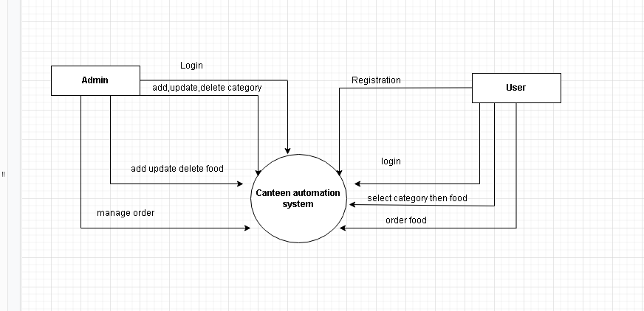

* **1st  LEVEL DFD FOR ADMIN:-**

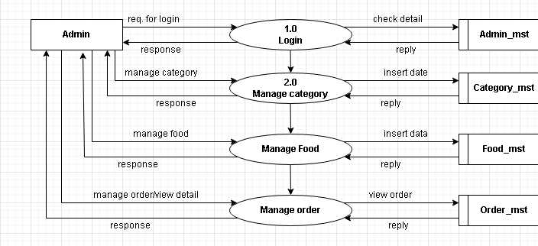

Data Flow Diagram

* **1st  LEVEL DFD FOR USER:-**

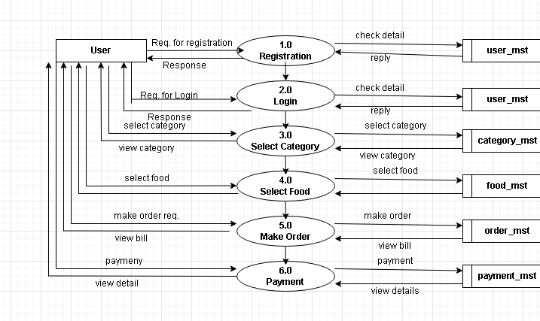

Process Specification

**3.3 Process Specification**

* **PROCESS 1.0 For USERS**

|  |  |
| --- | --- |
| Process Name | Login |
| Input | Email , Password |
| Output | Index page |
| Description | Customer will go to index page and do process for order food |

* **PROCESS 2.0 For USERS**

|  |  |
| --- | --- |
| Process Name | Register |
| Input | Full name , mobile no., email address , password |
| Output | Login page |
| Description | Customer will do register and login then go to index page and do process for order food. |

* **PROCESS 3.0 For USERS**

|  |  |
| --- | --- |
| Process Name | Order food |
| Input | Quantity, full name, phone no., email, address |
| Output | bill page |
| Description | Customer will do order food and gives canteen receipt. |

Process Specification

* **PROCESS 2.0 For ADMIN**

|  |  |
| --- | --- |
| Process Name | Login |
| Input | Username ,password |
| Output | Index page admin side |
| Description | Admin will do login into admin panel and admin also view all details and modify all details of food and category. |

* **PROCESS 2.0 For ADMIN**

|  |  |
| --- | --- |
| Process Name | Dashboard |
| Input | Category ,food ,orders ,revenue generated |
| Output | Count of category ,food ,total order and total of price delivered order |
| Description | Count of category ,food ,total order and total of price delivered order |

* **PROCESS 2.0 For ADMIN**

|  |  |
| --- | --- |
| Process Name | Manage category |
| Input | Id ,title ,image ,active |
| Output | View category |
| Description | Admin will Manage food category title ,image , items type perform add , update , delete. |

* **PROCESS 2.0 For ADMIN**

|  |  |
| --- | --- |
| Process Name | Manage food |
| Input | Id ,title ,price ,image ,active |
| Output | View food |
| Description | Admin will Manage food title ,price ,image , category-id , items type perform add , update , delete. |

Process Specification

* **PROCESS 2.0 For ADMIN**

|  |  |
| --- | --- |
| Process Name | Manage order |
| Input | Id ,food ,price ,qty , total ,order-date ,status , customer name , contact ,email , address |
| Output | View customer orders |
| Description | Admin will Manage order and status items type perform update , delete. |

Design

**4.Design**

**4.1 E-R Diagram:-**

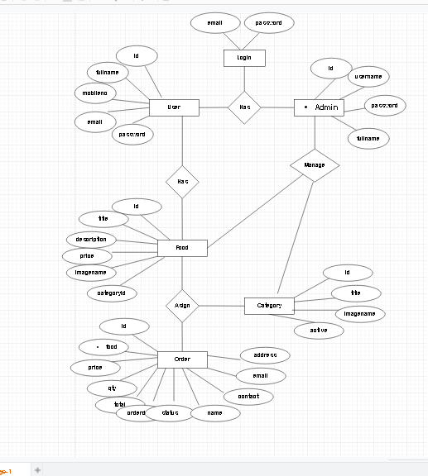

Design

**4.2 Database Design:**

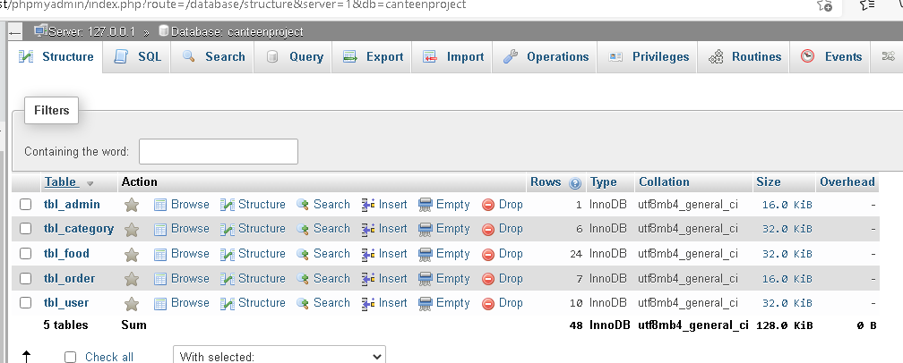

* Table Name : **tbl_admin**

|  |  |  |  |  |
| --- | --- | --- | --- | --- |
| **Field Name** | **Data Type** | **Constraints** | **Field Size** | **Description** |
| **Id** | Auto Number | Primary Key |  | Contains ID of  Admin |
| **full_name** | Varchar |  | 30 | Contains  name of  admin |
| **username** | Varchar |  | 30 | Contains  username of  patients |
| **Password** | Varchar |  | 30 | password of  admin |

* Table Name : **tbl_category**

|  |  |  |  |  |
| --- | --- | --- | --- | --- |
| **Field Name** | **Data Type** | **Constraints** | **Field Size** | **Description** |
| **Id** | Auto  Number | Primary  Key |  | Contains ID  of admin |
| **Title** | Varchar |  | 50 | Contains title of category |
| **Image_name** | Varchar |  | 255 | Contains image of category |
| **active** | Varchar |  | 10 | Contains active |

Design

* Table Name : **tbl_food**

|  |  |  |  |  |
| --- | --- | --- | --- | --- |
| **Field Name** | **Data Type** | **Constraints** | **Field Size** | **Description** |
| **Id** | Auto  Number | Primary  Key |  | Contains ID  of admin |
| **Title** | Varchar |  | 50 | Contains title of category |
| **Description** | varchar |  |  | Details of food |
| **Price** | decimal |  | 10,2 | Price of food |
| **Image_name** | Varchar |  | 255 | Contains image of category |
| **Category_id** | int |  | 10 | Category id of food |
| **active** | Varchar |  | 10 | Contains active |

* Table Name : **tbl_order**

|  |  |  |  |  |
| --- | --- | --- | --- | --- |
| **Field Name** | **Data Type** | **Constraints** | **Field Size** | **Description** |
| **Id** | Auto  Number | Primary  Key |  | Contains ID  of admin |
| **Food** | Varchar |  | 150 | Contains title of category |
| **Price** | decimal |  | 10,2 | Price of food |
| **Qty** | int |  | 11 | Qty of food |
| **total** | decimal |  | 10,2 | Total=qty*price |
| **Order_date** | datetime |  |  | Orders date |
| **Status** | varchar |  | 50 | Status of order |
| **Customer_name** | varchar |  | 20 | Name of customer |
| **Customer_contact** | varchar |  | 20 | Contact of customer |
| **Customer_email** | varchar |  | 50 | Email of customer |
| **Customer_address** | varchar |  | 100 | Address of customer |

Design

* Table Name : **tbl_user**

|  |  |  |  |  |
| --- | --- | --- | --- | --- |
| **Field Name** | **Data Type** | **Constraints** | **Field Size** | **Description** |
| **Id** | Auto Number | Primary Key |  | Contains ID of  Admin |
| **full_name** | Varchar |  | 30 | Contains  name of  customer |
| **Mobile no.** | varchar |  | 11 | Mobile no . of customer |
| **Email id** | Varchar |  | 30 | Contains  email of  customer |
| **Password** | Varchar |  | 30 | password of  customer |

System Flowchart

**4.3 System Flowchart :**

**4.3.1 Admin Side :**

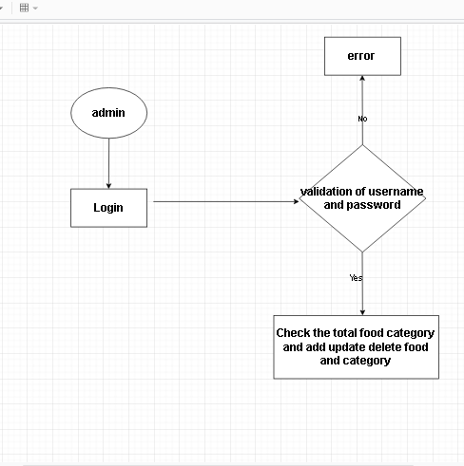

**4.3.1 User Side :**

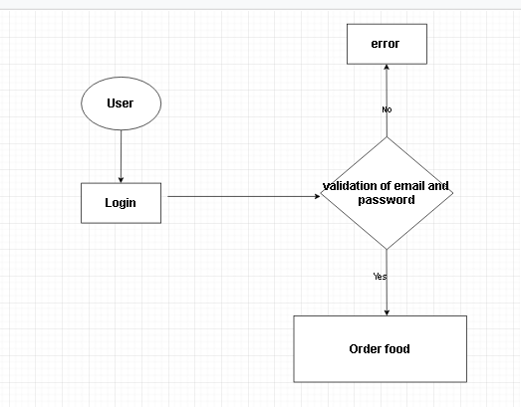

REPORT DESIGN

**4.4 FORM AND REPORT DESIGN (SCREENSHOT) LAYOUT:**

* **Login Page For Admin**
* Login Page Used by Admin to login in canteen

system and manage food ,category.

* Login done with username And password.
* If admin put the wrong email or password then system gives error.

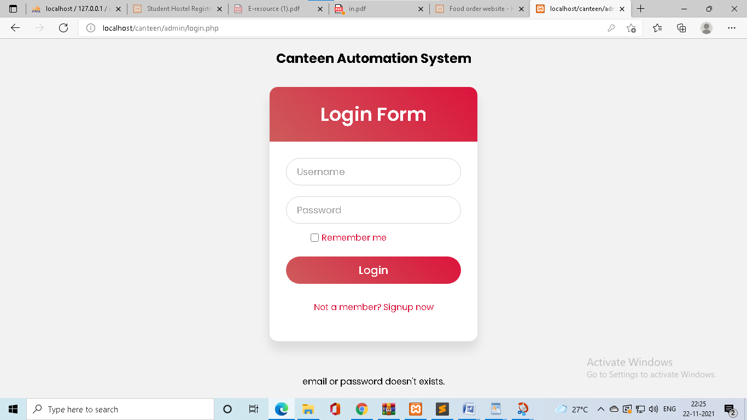

* If admin login right username or password then page redirect index page
* In this page admin view total categories , total food , total order and revenue generated.
* **Admin Home Page**

REPORT DESIGN

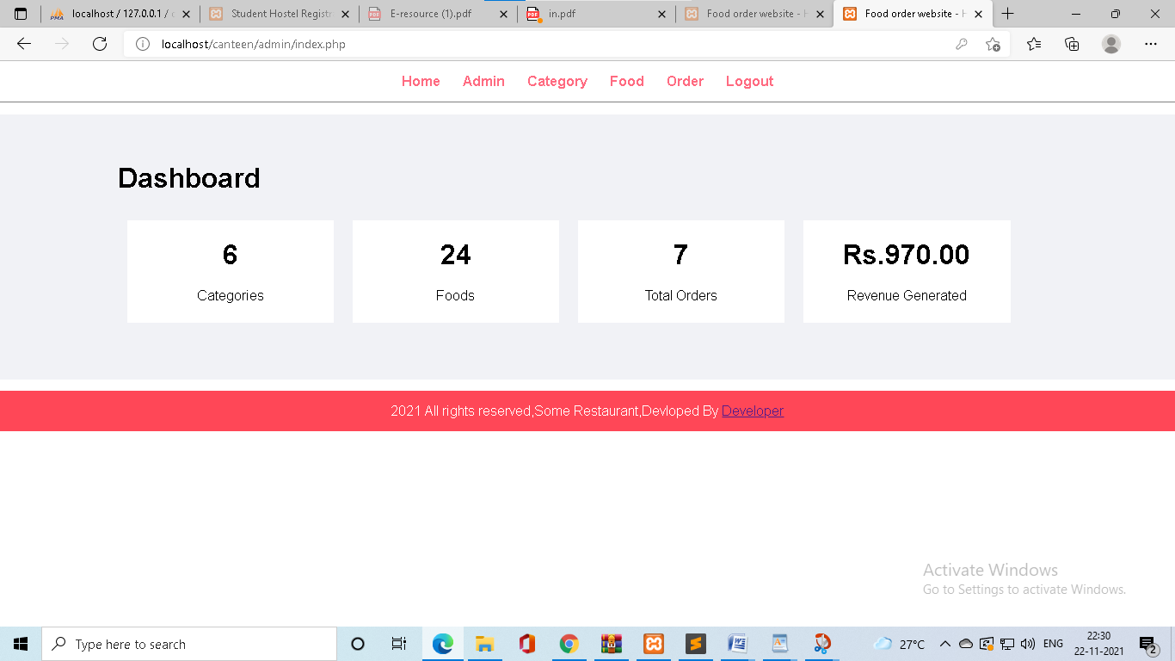

* **Admin Change Password**
* In This index page, Admin can change their

Password if any fraud by any side.

* Here, we add a feature called change password.

REPORT DESIGN

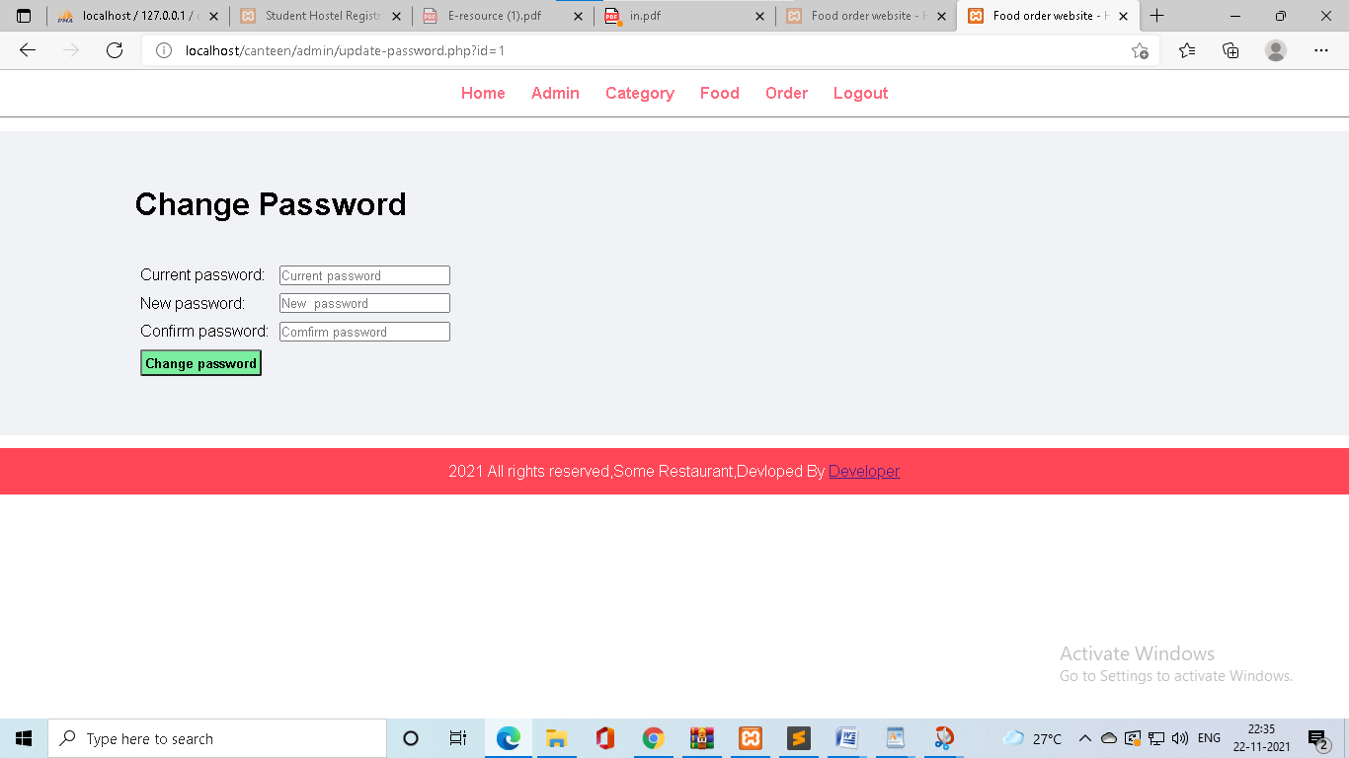

* **Admin update details**
* Here, Also we admin update his details

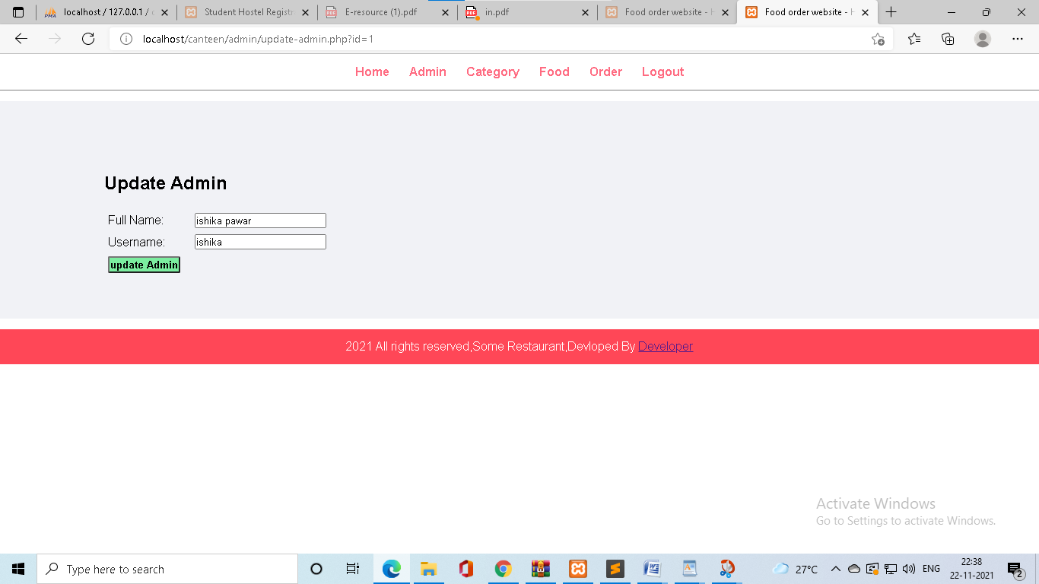

REPORT DESIGN

* **Admin manage category**
* Here admin can add , update , delete category.
* Admin also add and update category image.

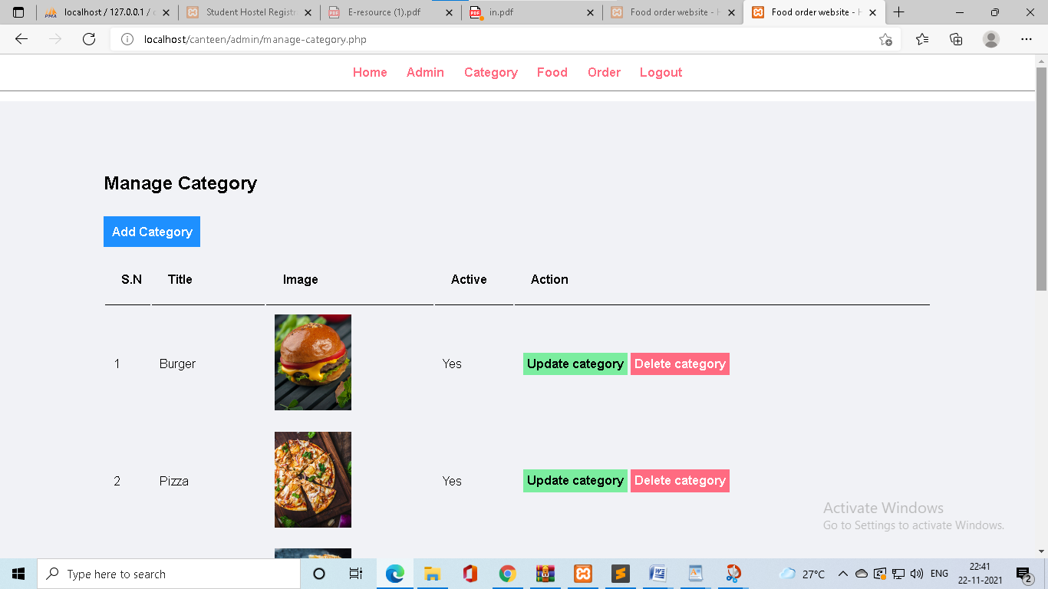

* **Admin category add**

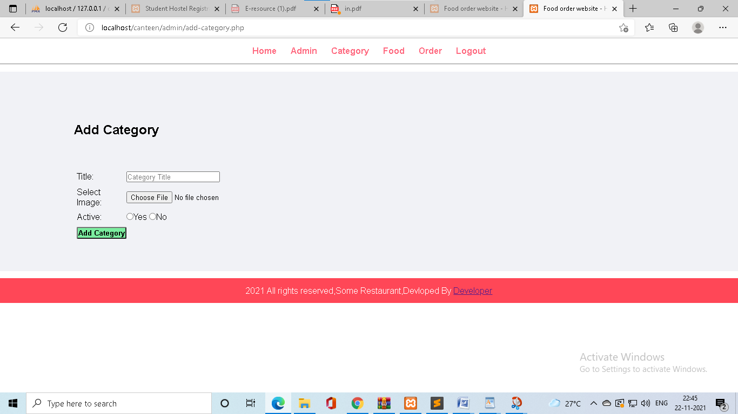

REPORT DESIGN

* **Admin category update**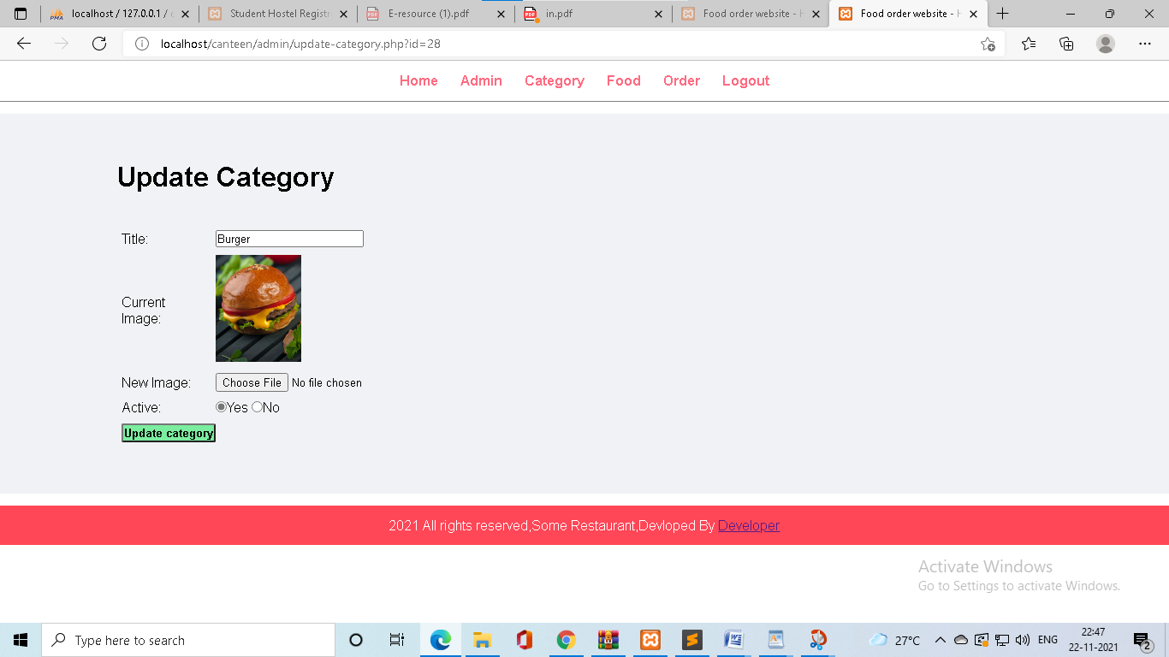
* **Admin manage food**
* Here admin can add , update , delete food.
* Admin also add and update food image.

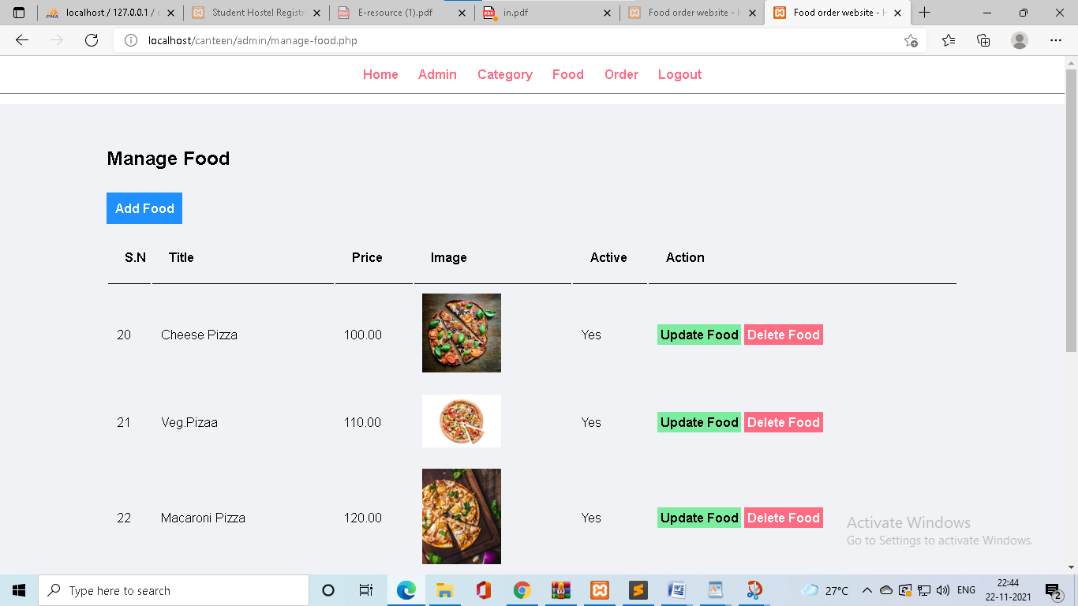

REPORT DESIGN

* **Admin food add**

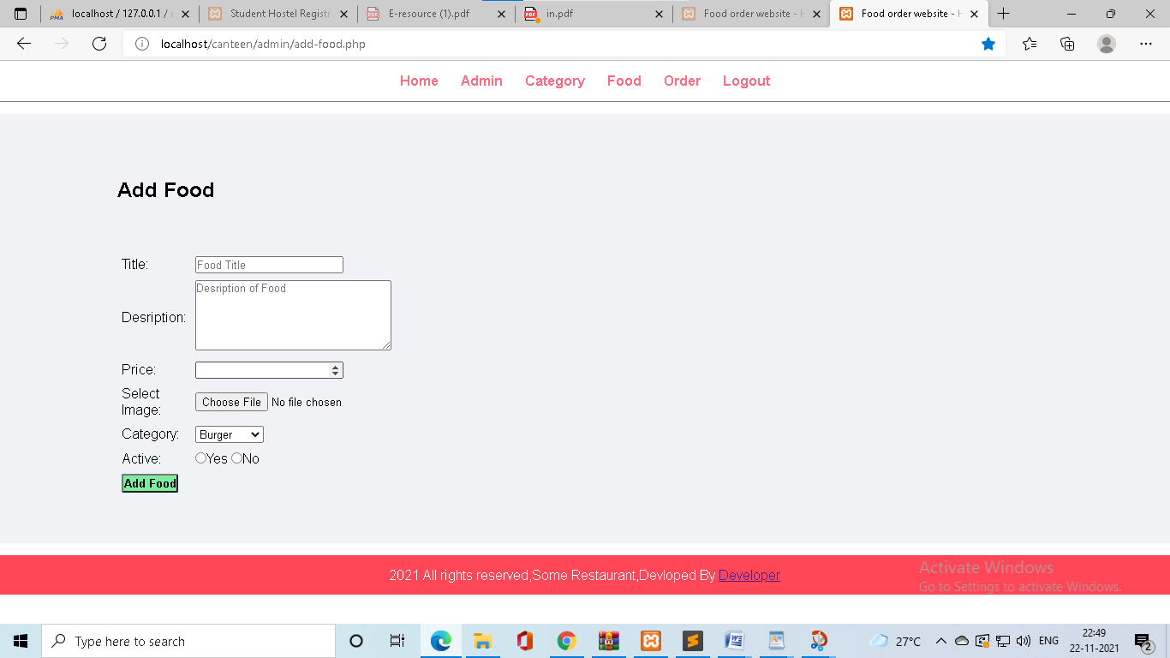

* **Admin food update**

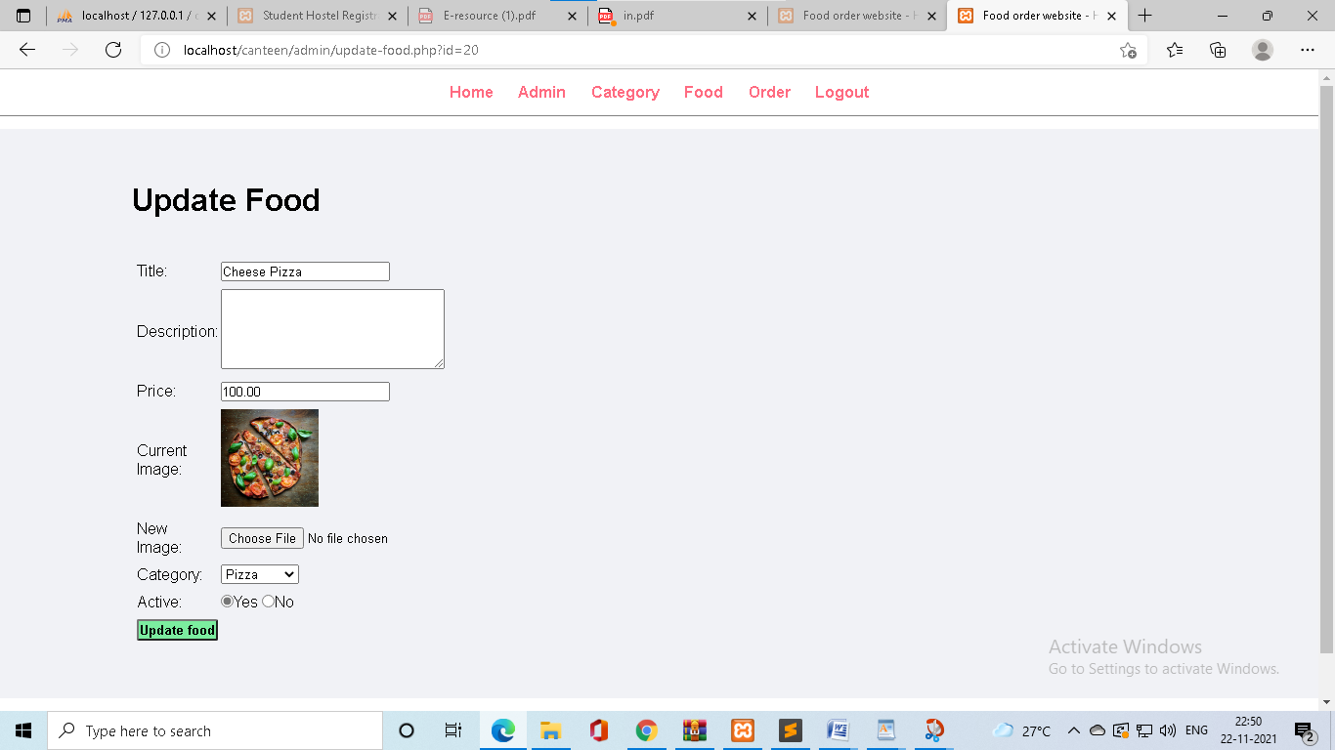

REPORT DESIGN

* **Admin manage orders**
* Admin only can update orders status and delete order.
* Admin view the all order details.

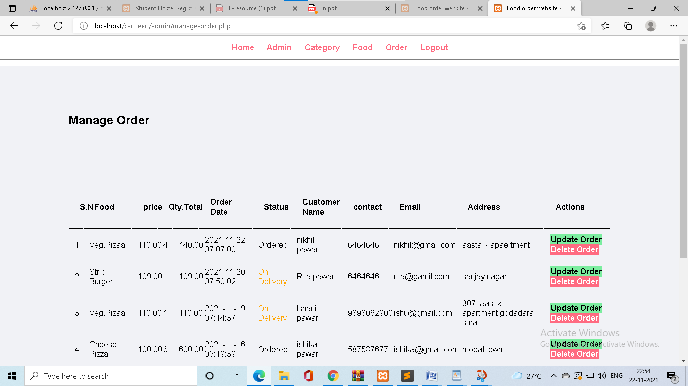

* **Admin update orders**

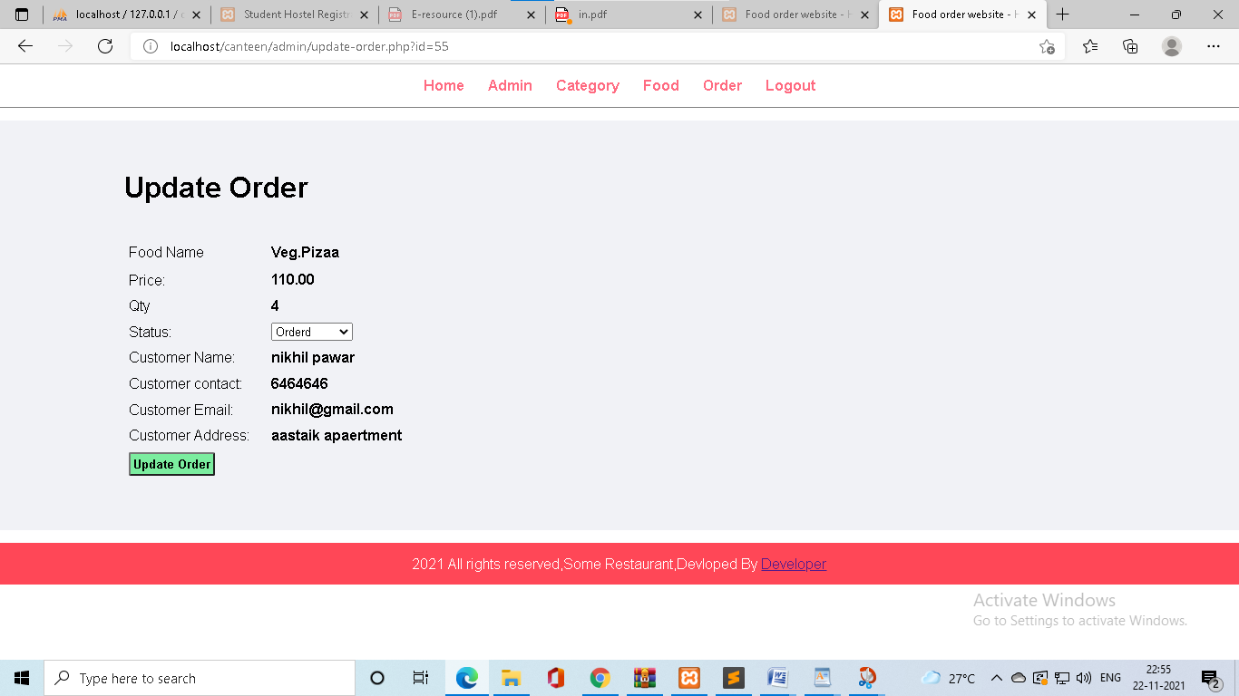

REPORT DESIGN

* **User registration page.**
* User can register his details.
* Then user can login and redirect index/home page.
* Then order the food.

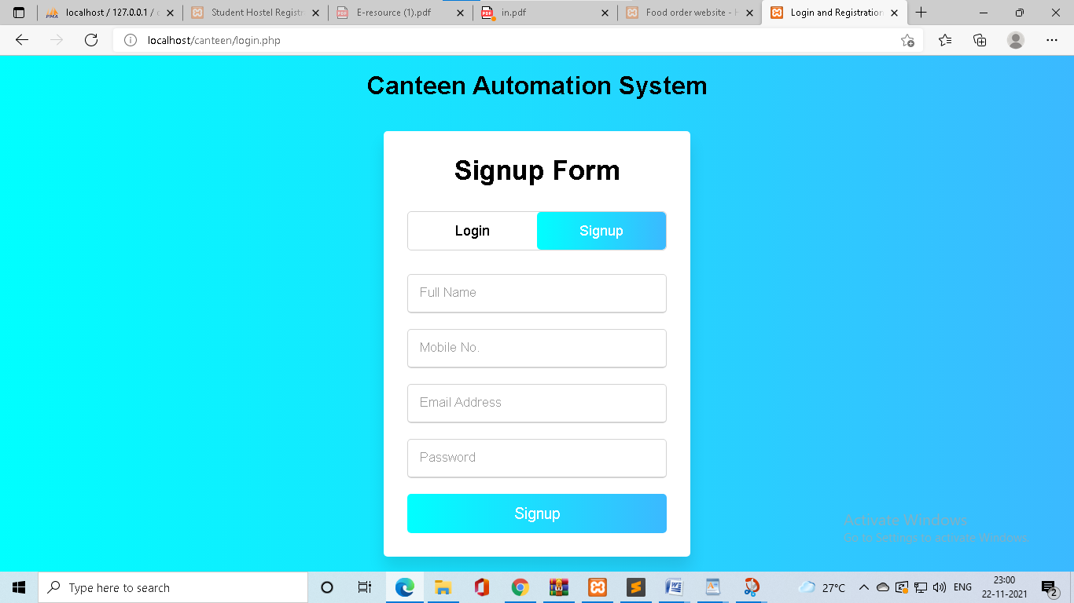

* **Login Page For user**
* Login Page Used by users order the food.
* Login done with username And password.

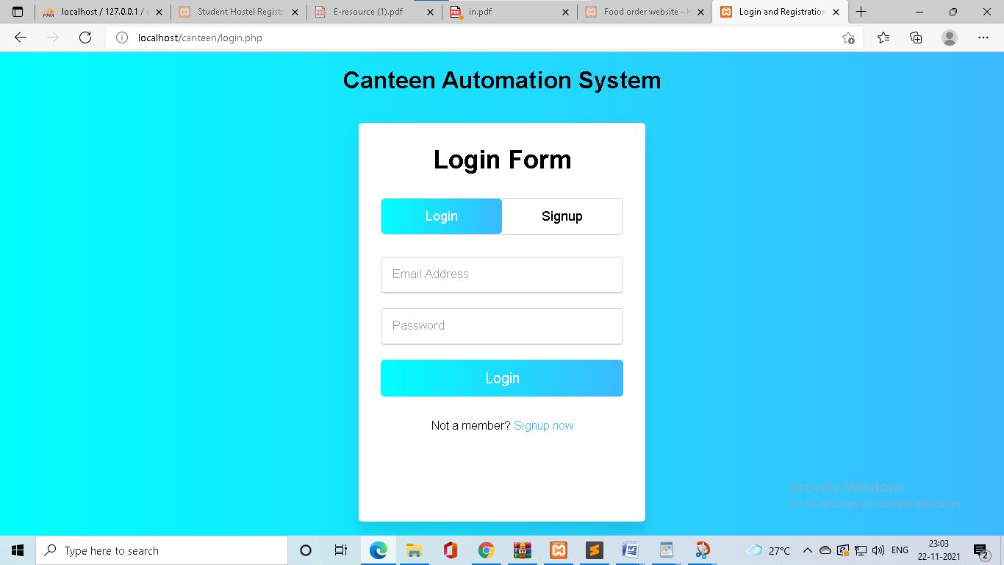

REPORT DESIGN

* **Index page For user**
* In this page user see the food and category search box.
* User can order the food.

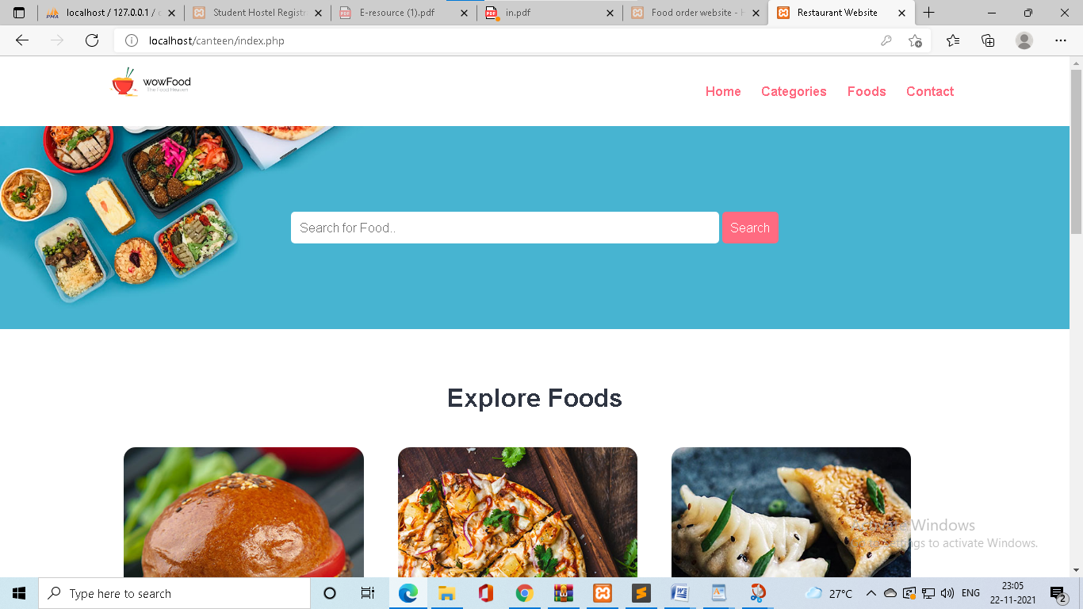

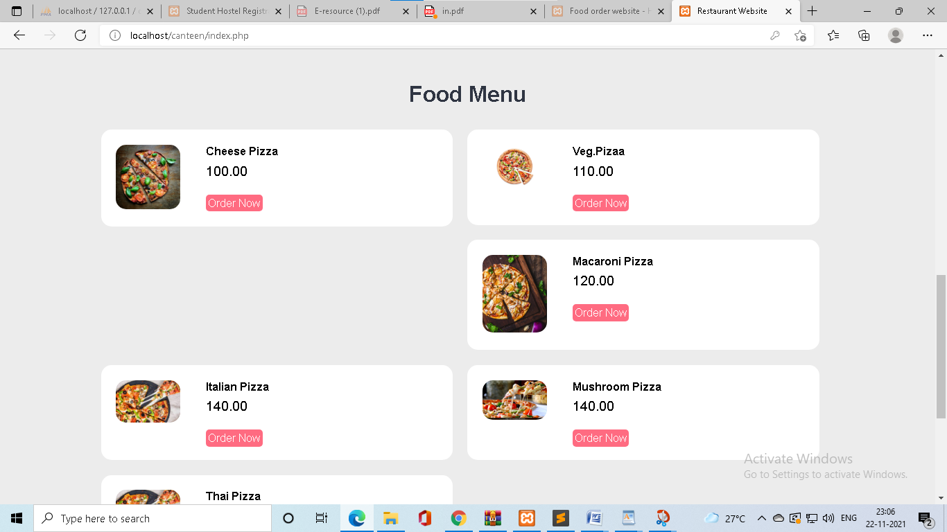

REPORT DESIGN

* **categories page For user**
* In this page user cliked the category image then user redirect category-food page.

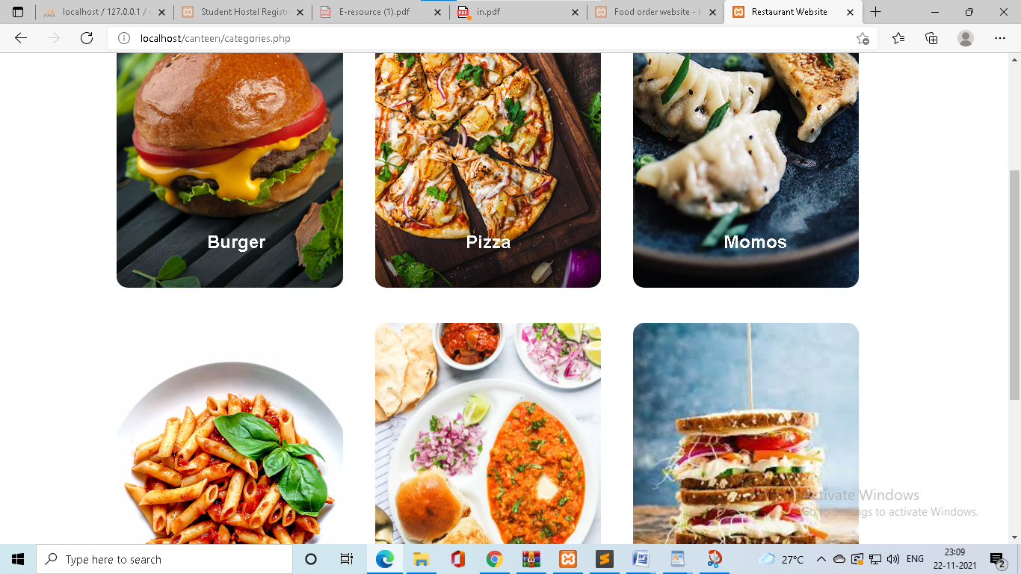

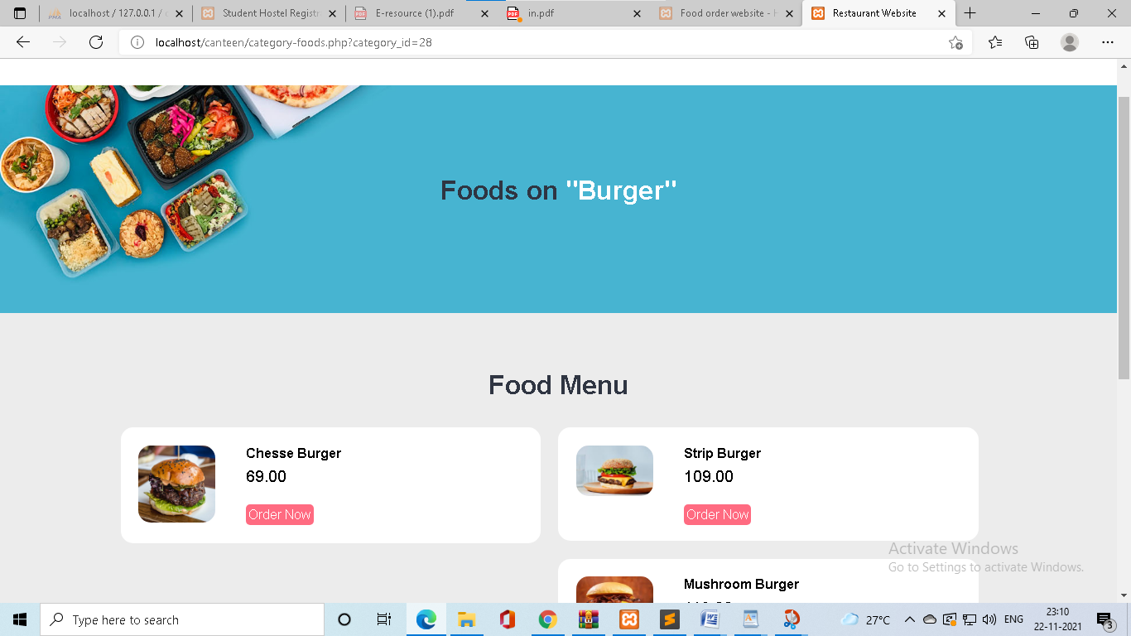

REPORT DESIGN

* **Food page**
* User can only see food.

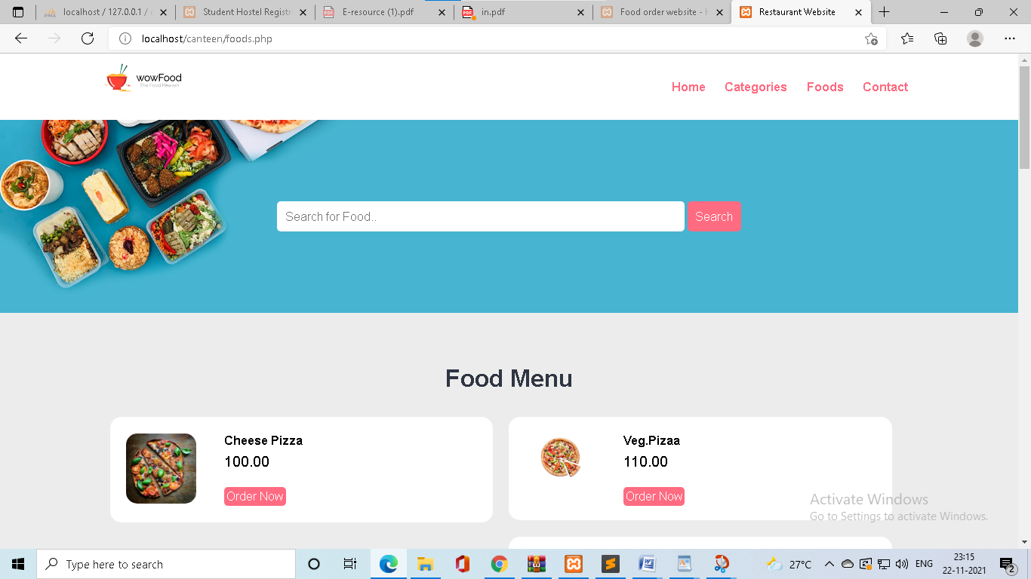

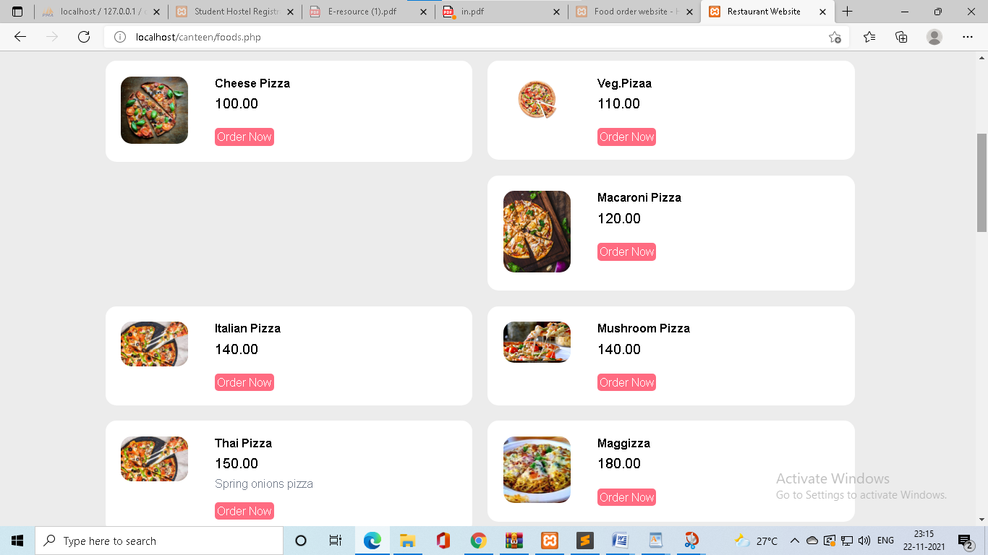

REPORT DESIGN

* **order page**
* when user cliked order now button then open order page
* user can fill all detais and order the food.

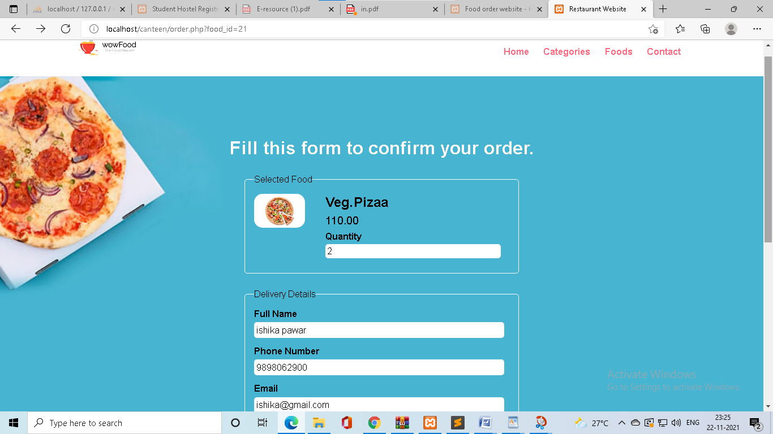

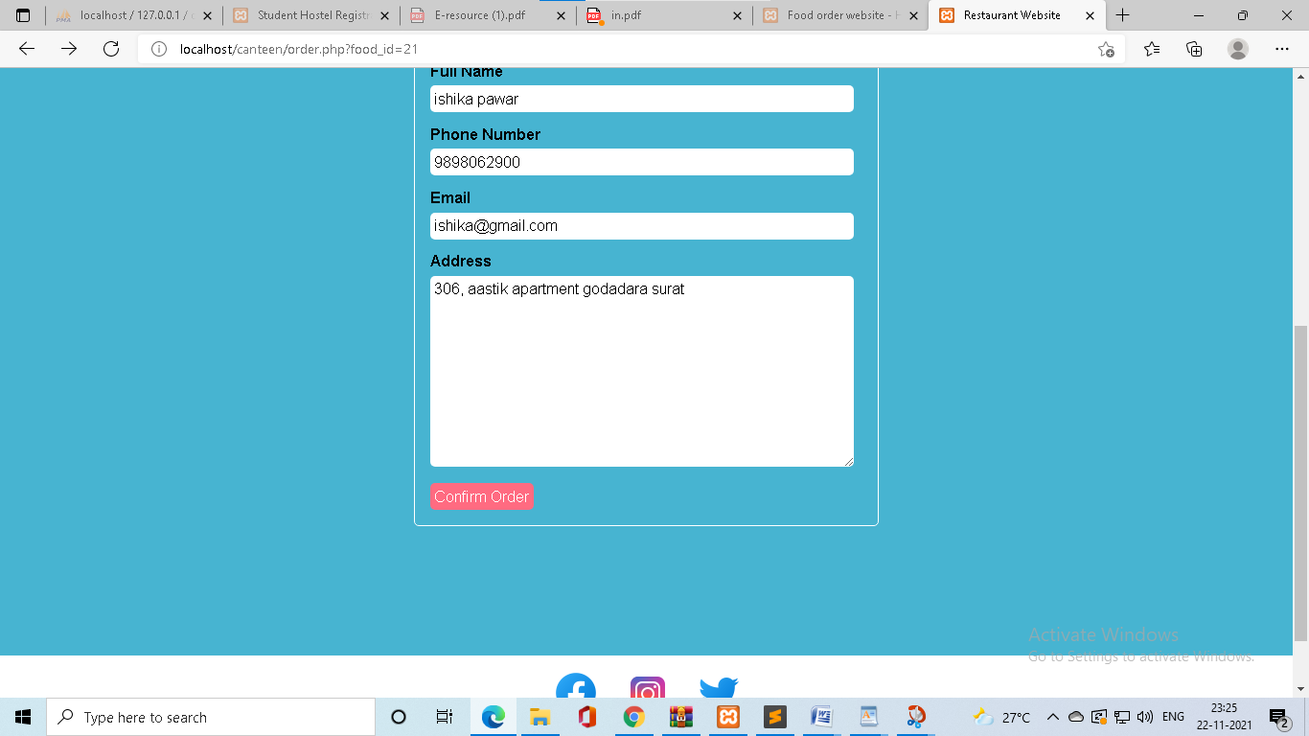

REPORT DESIGN

* **Bill page**
* Customers canteen receipt.
* Payment only cash on delivery.

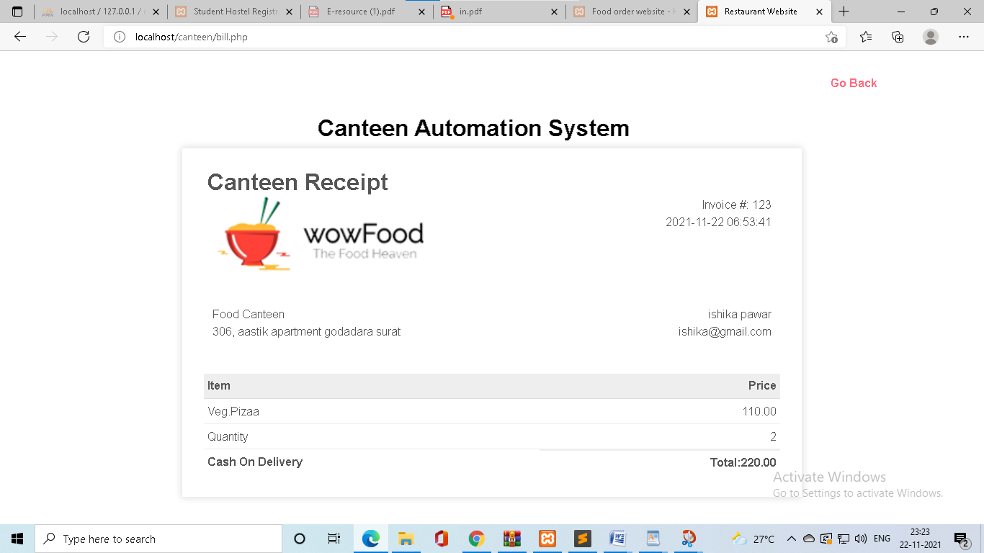

CODEING

**5.CODEING**

* **Admin login Page**

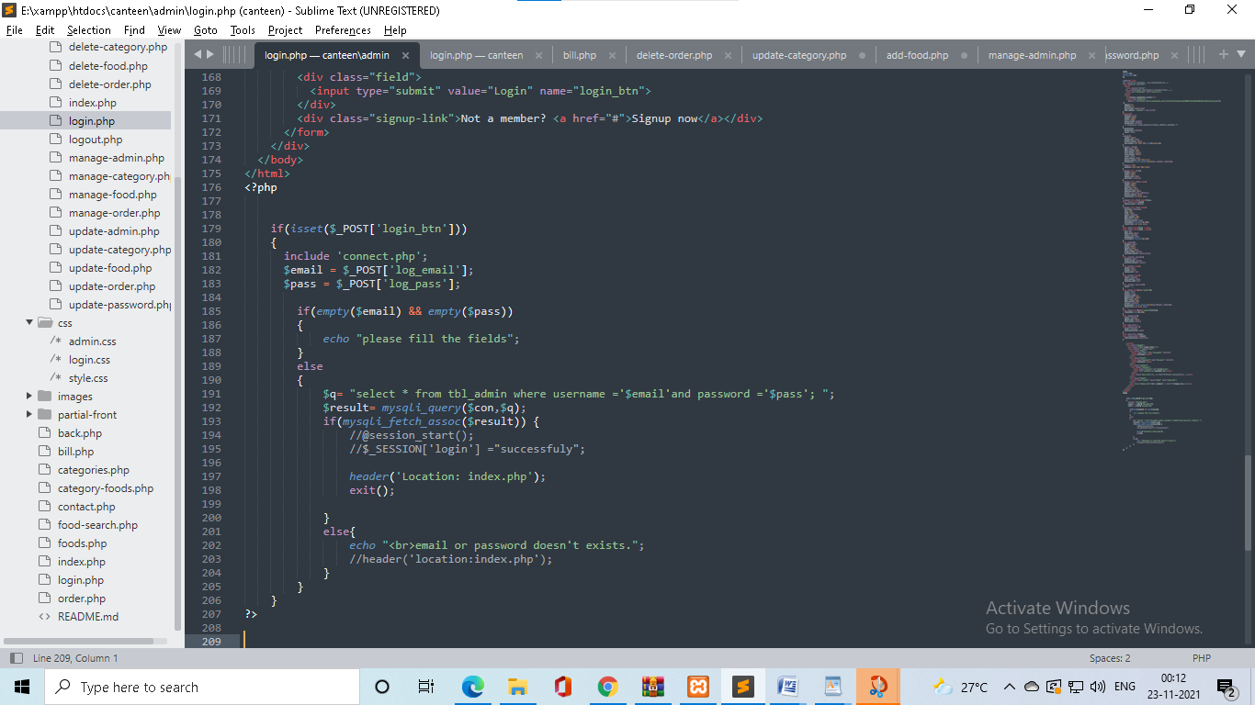

* **Admin Index Page**

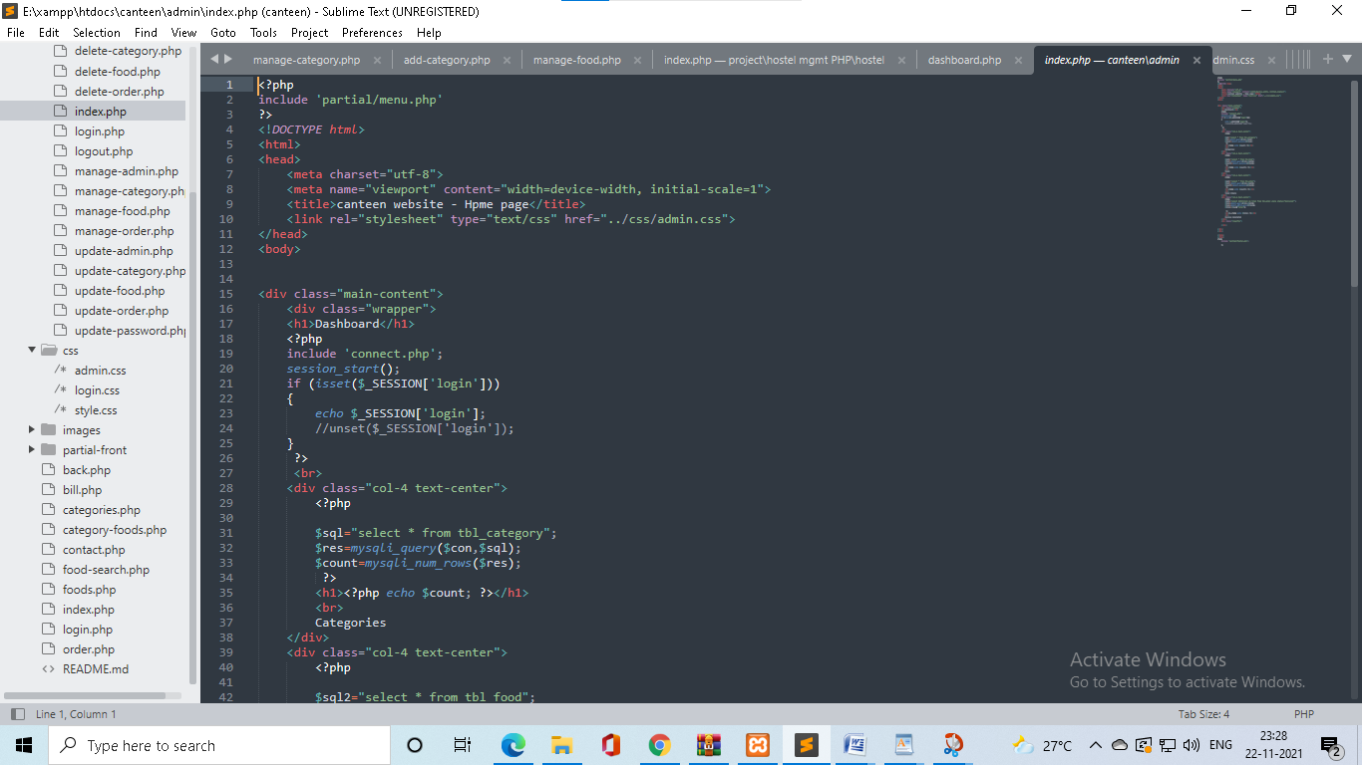

CODEING

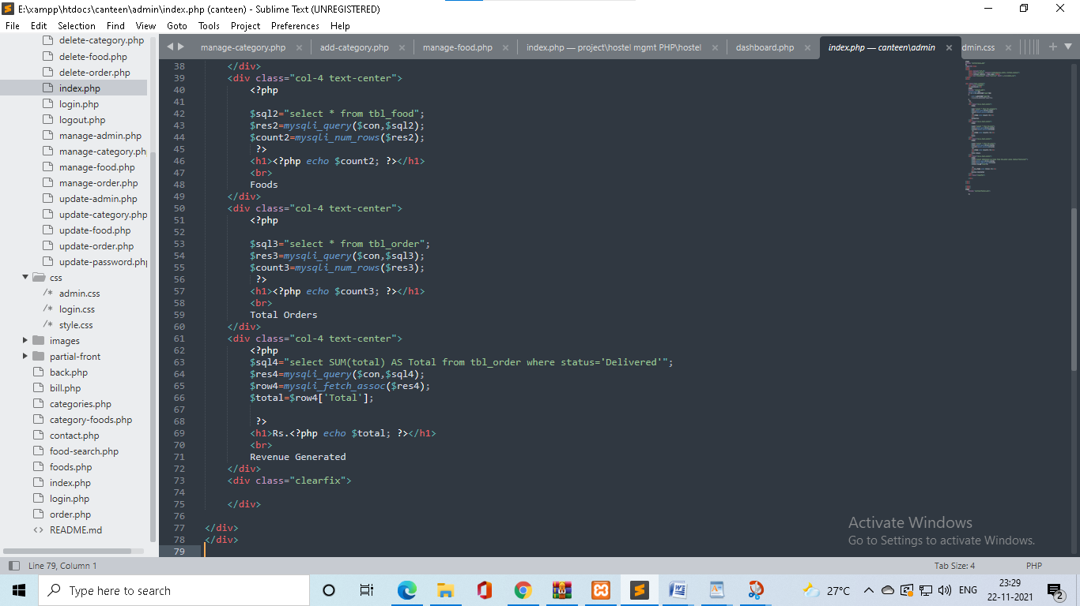

* **Admin manage Admin**

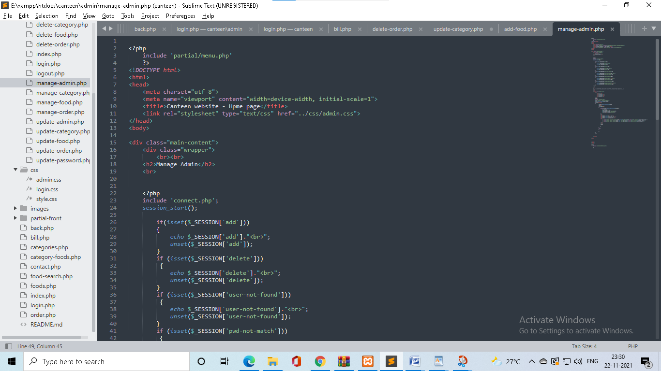

CODEING

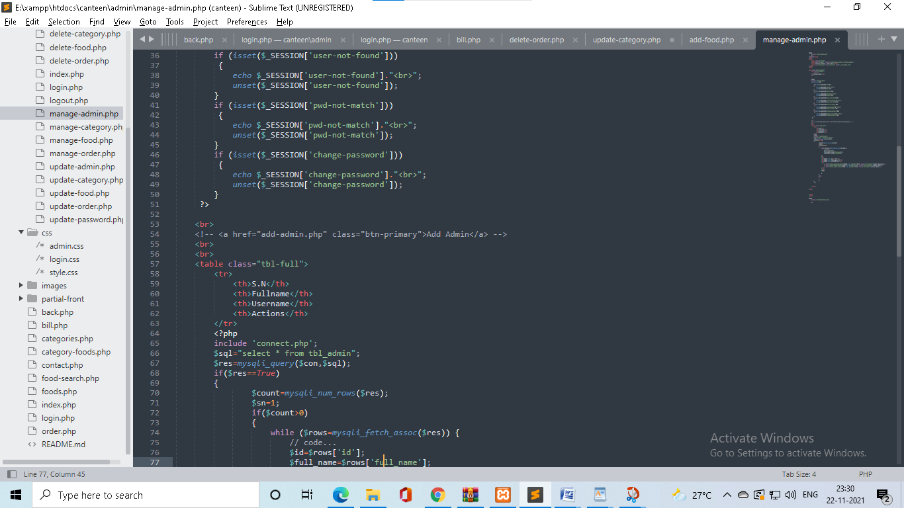

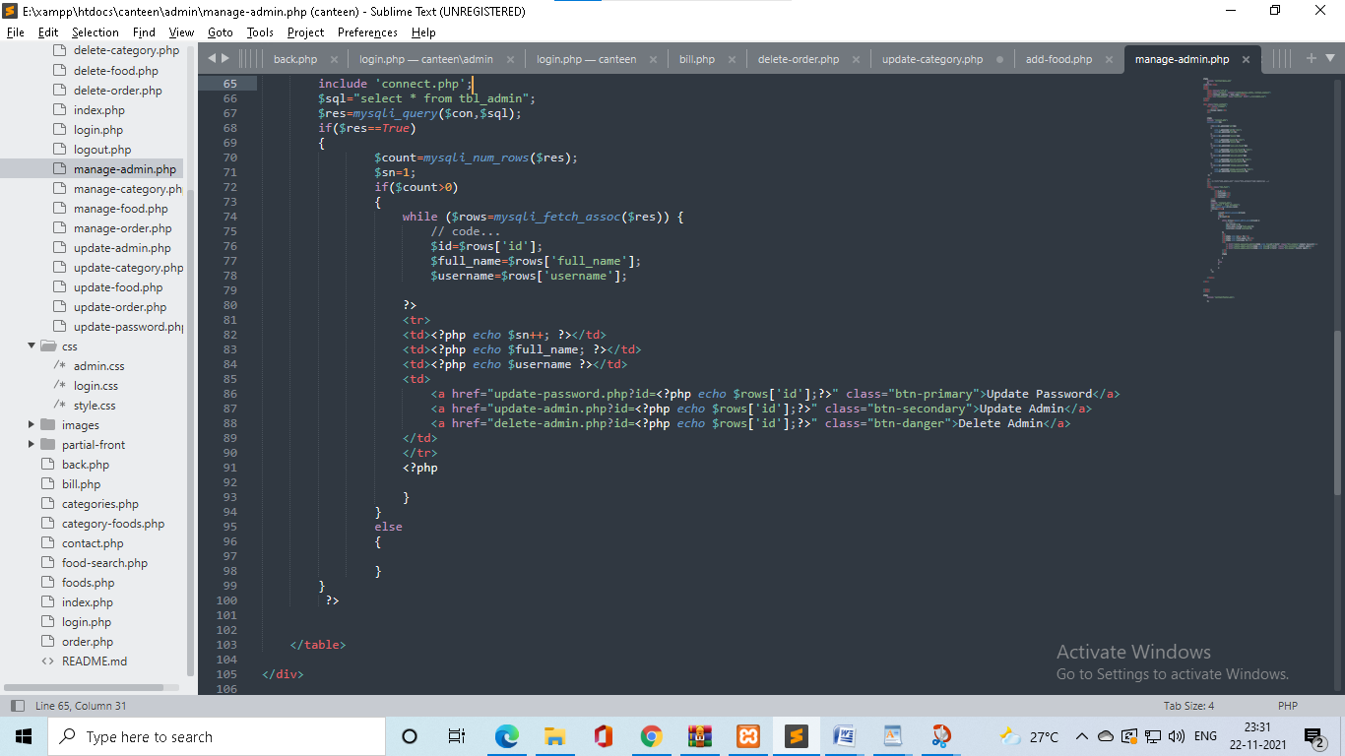

CODEING

* **Admin change password**

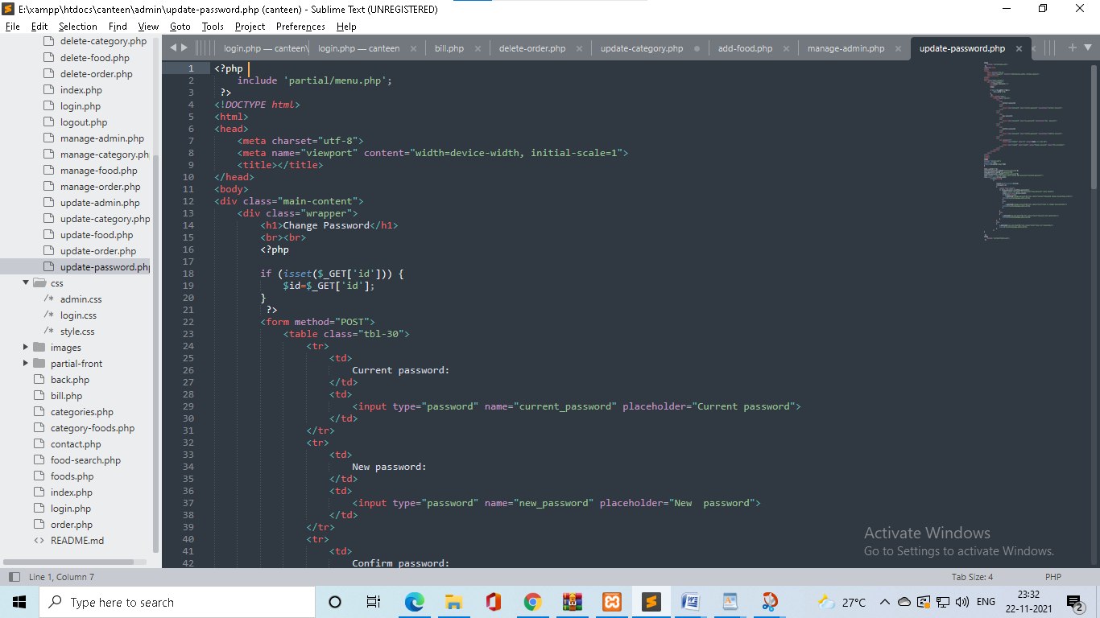

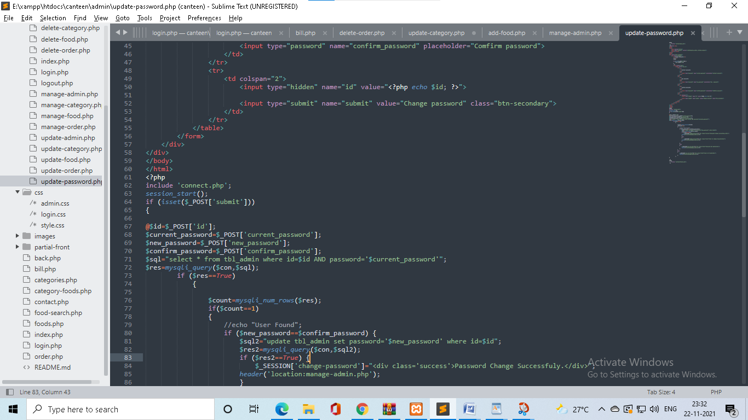

CODEING

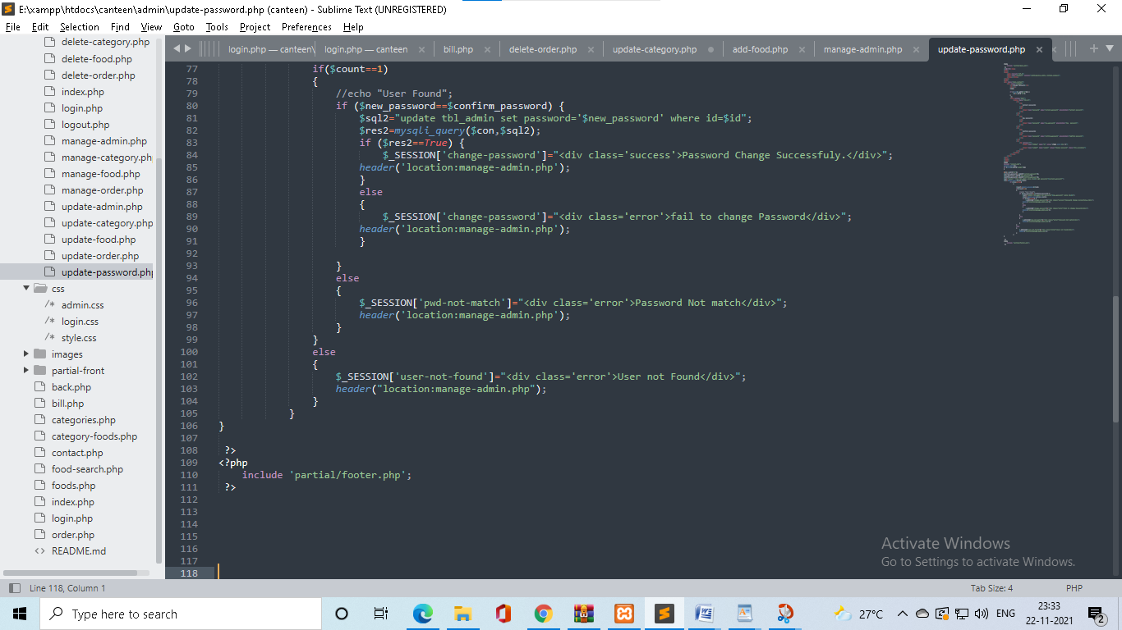

* **Admin update**

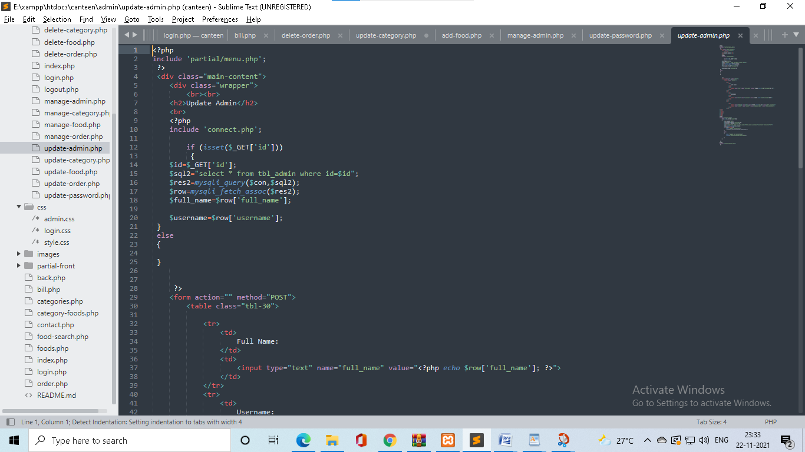

CODEING

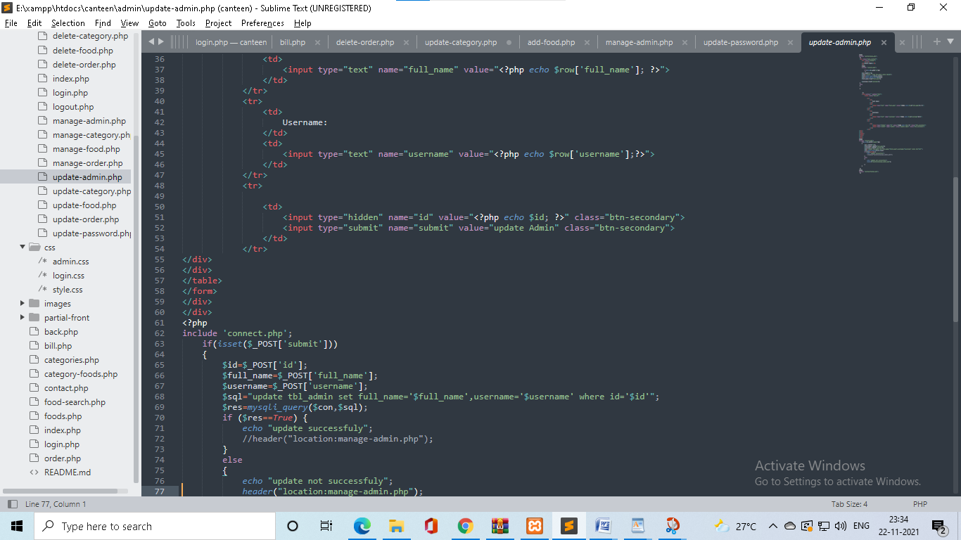

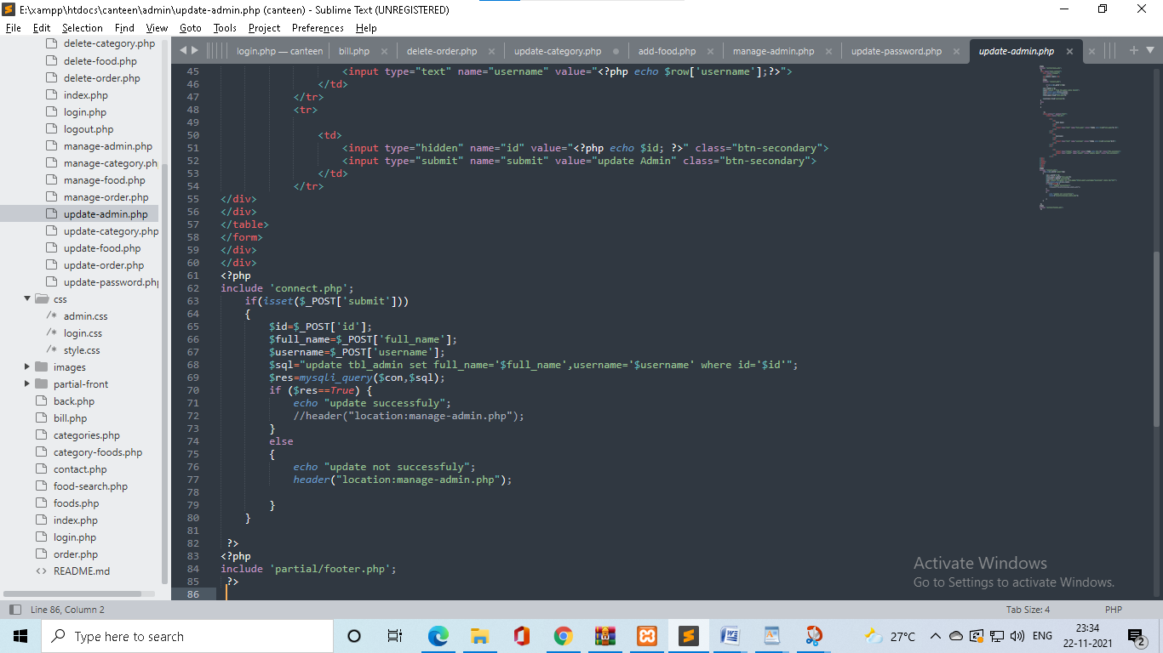

CODEING

* **Admin delete**

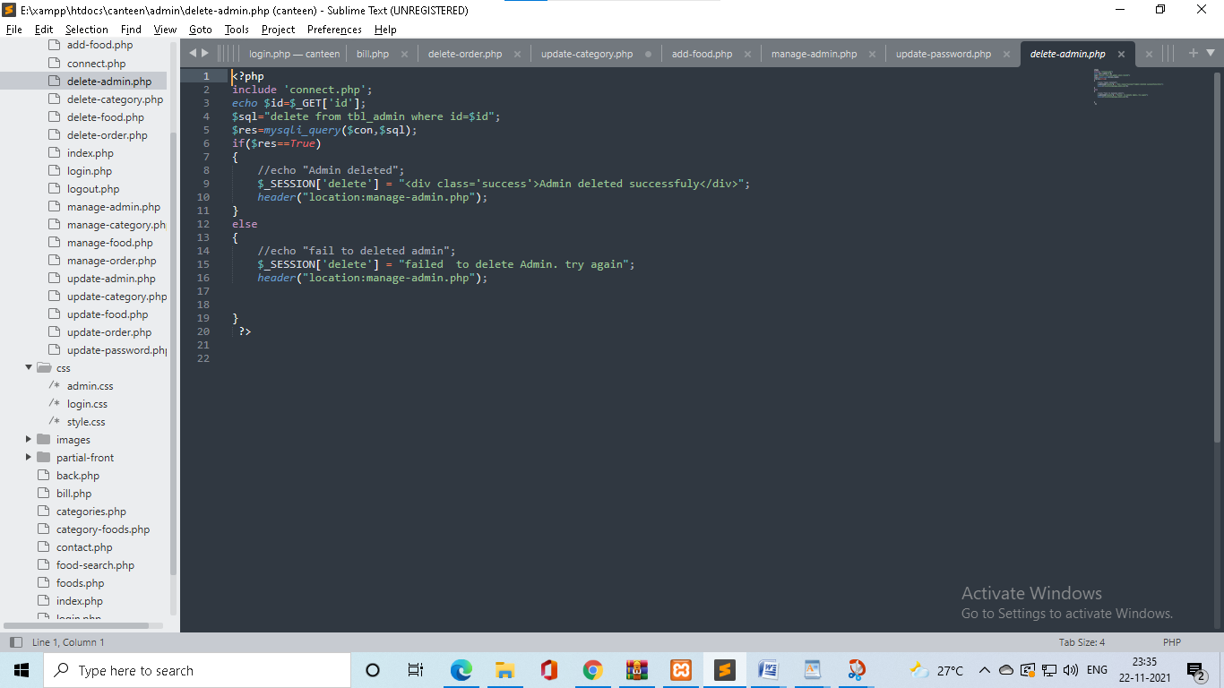

* **Category add page**

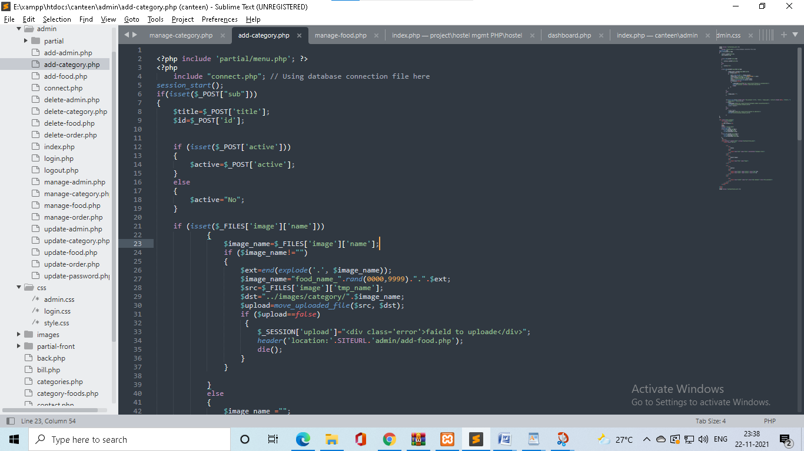

CODEING

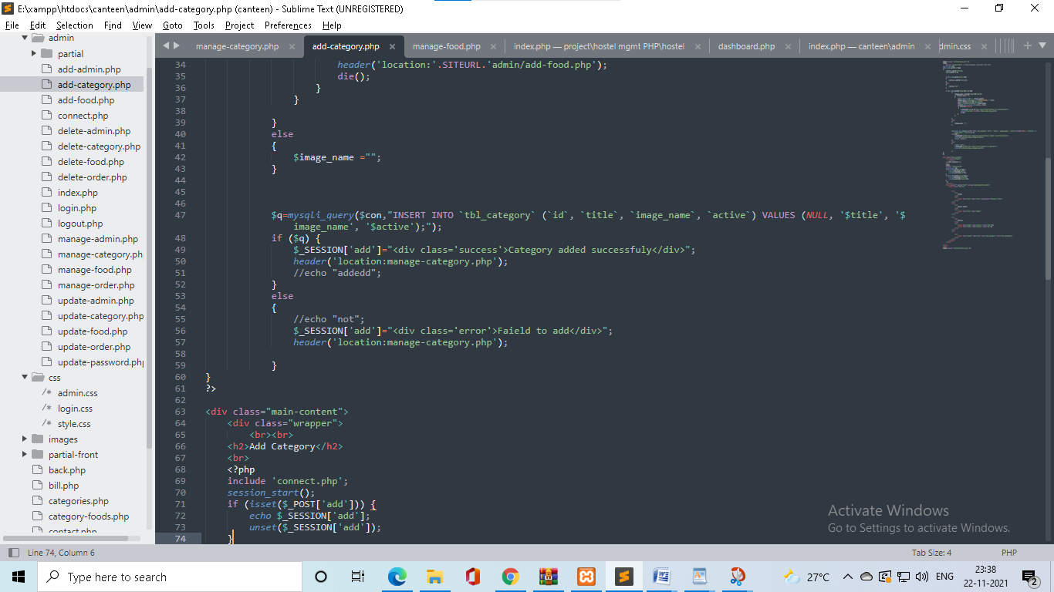

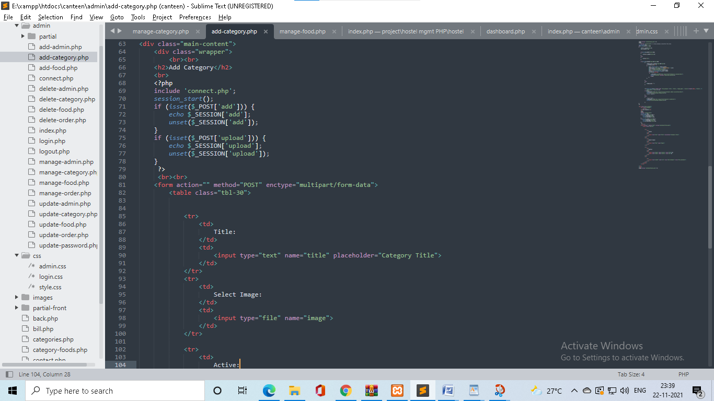

CODEING

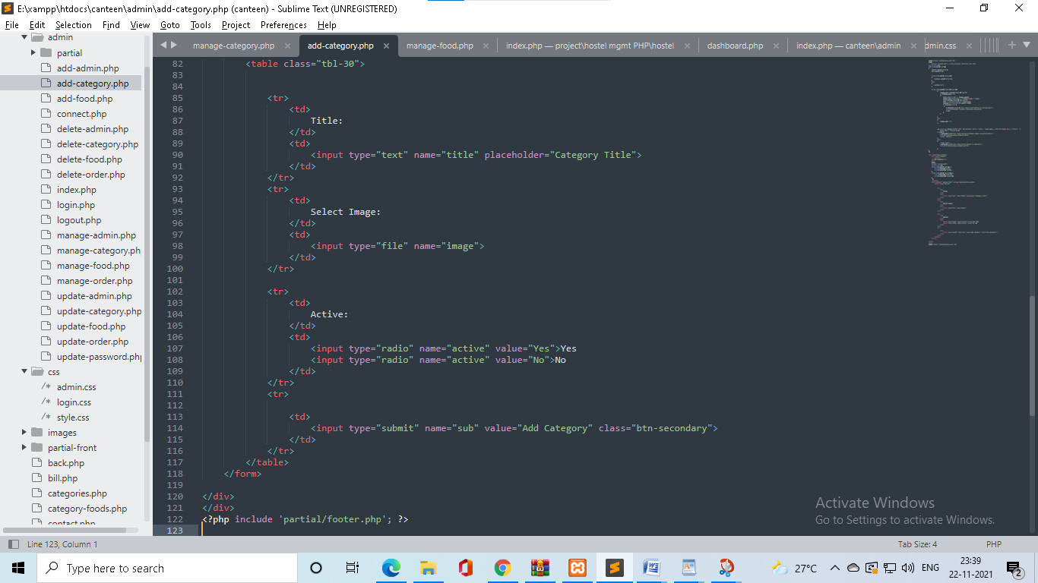

* **Manage food page**

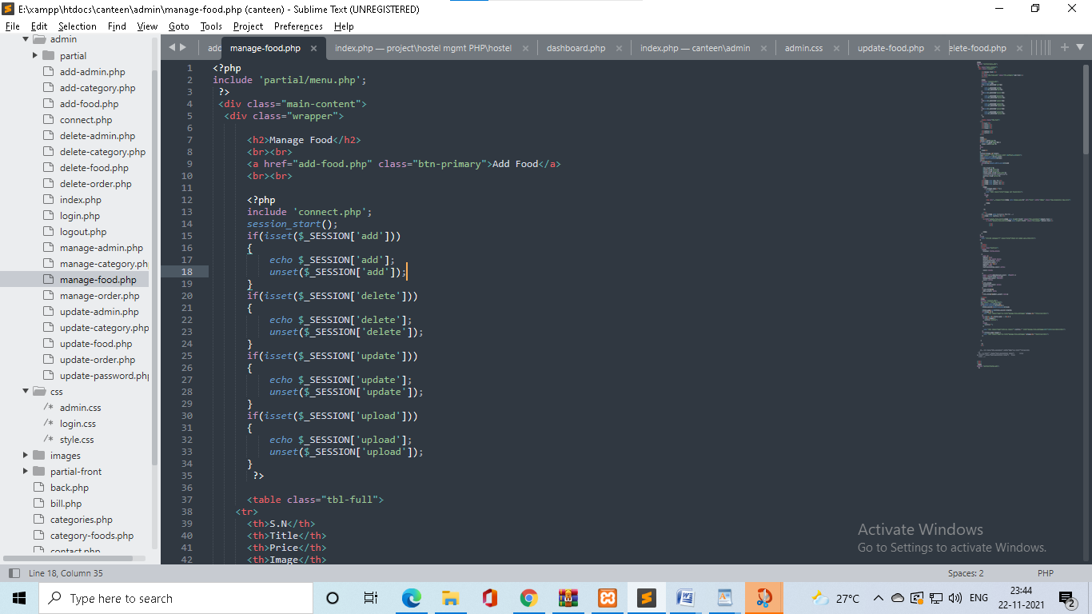

CODEING

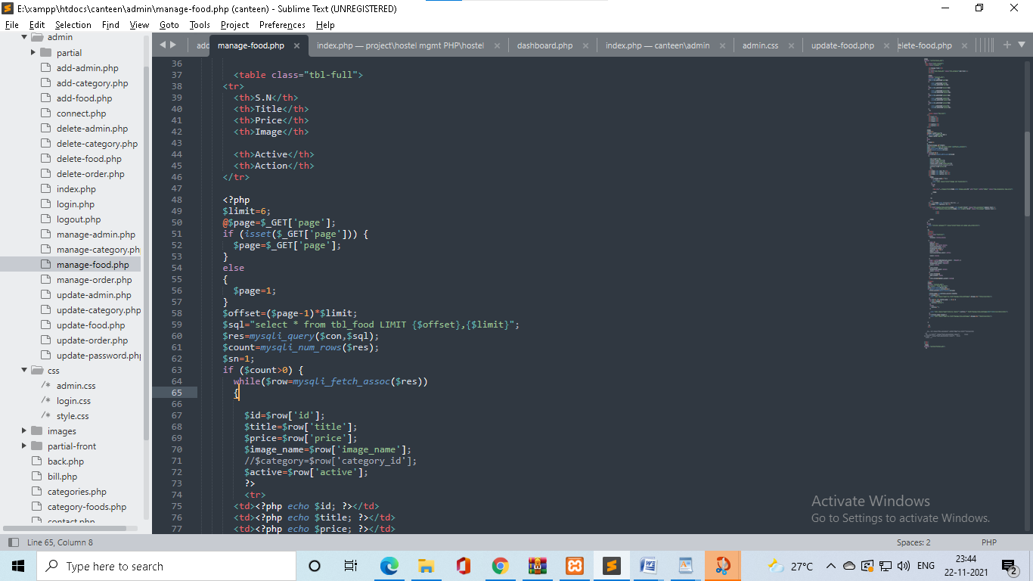

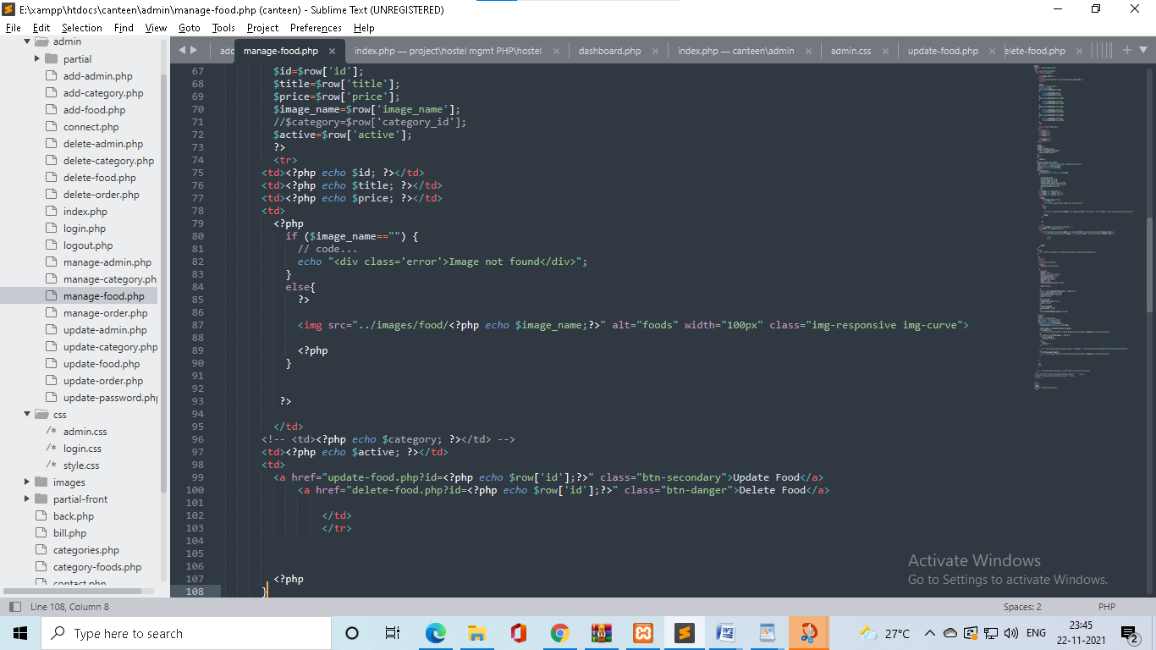

CODEING

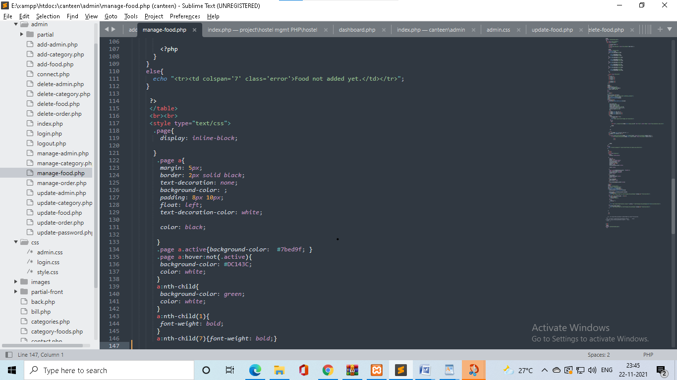

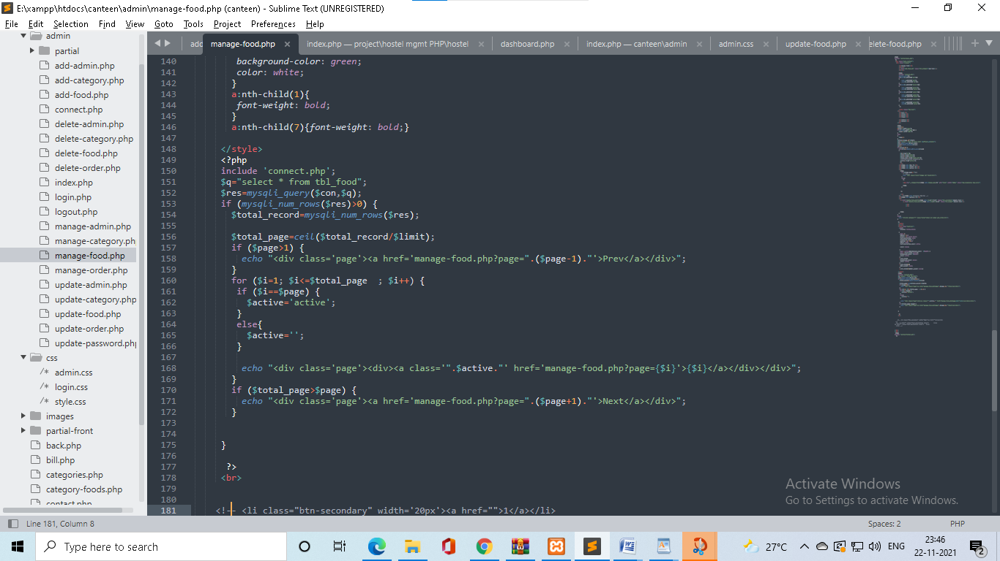

CODEING

* **Food add page**

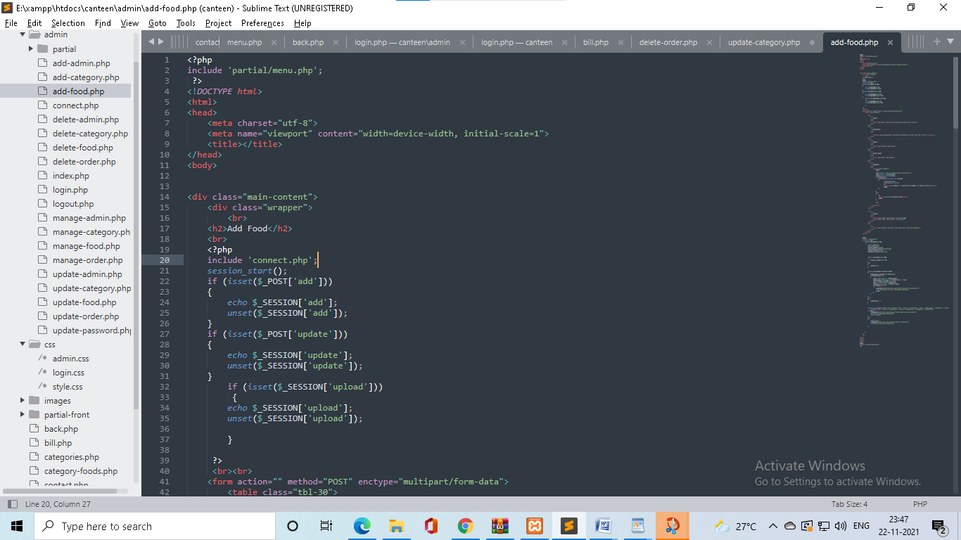

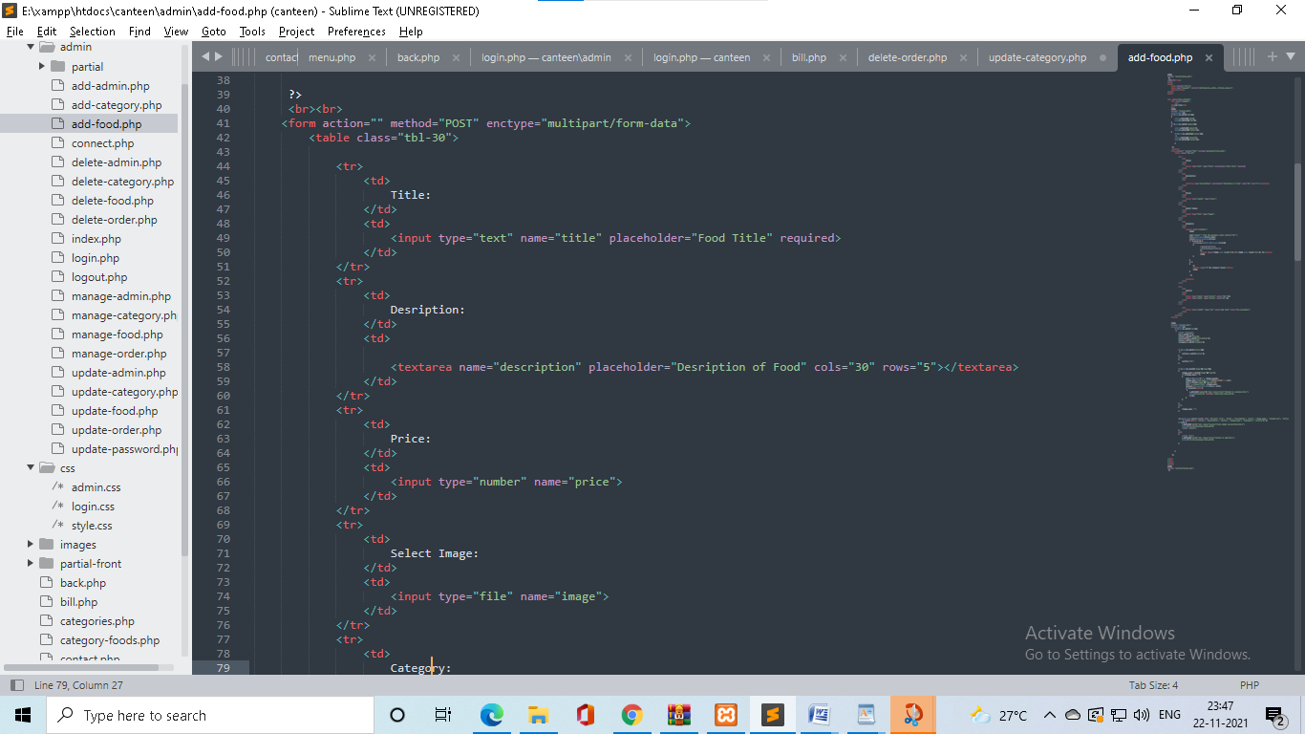

CODEING

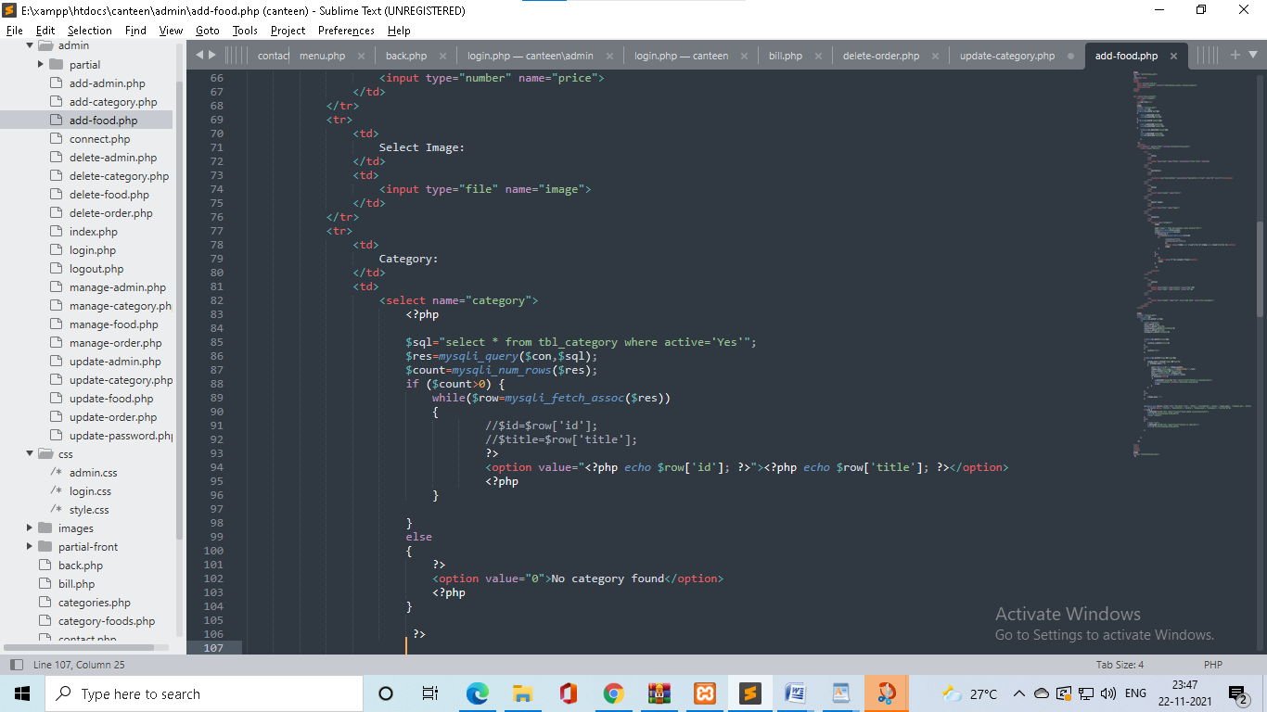

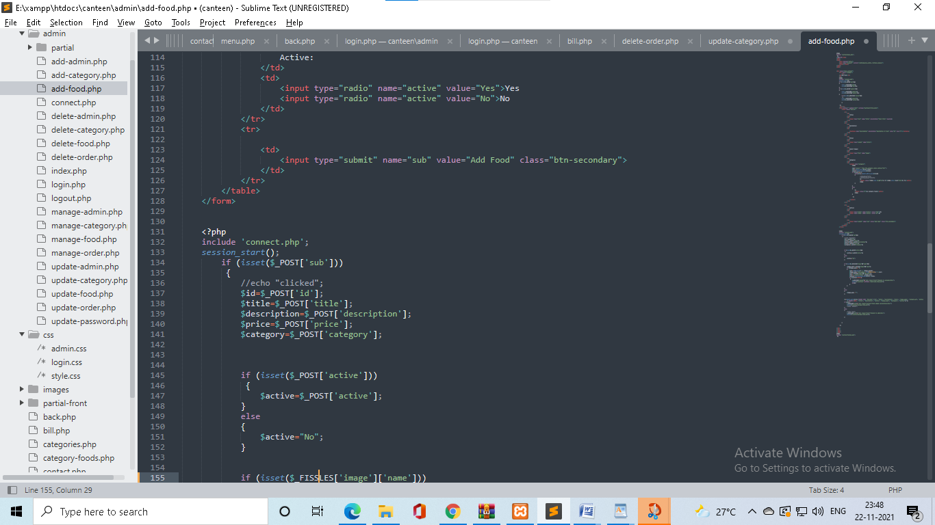

CODEING

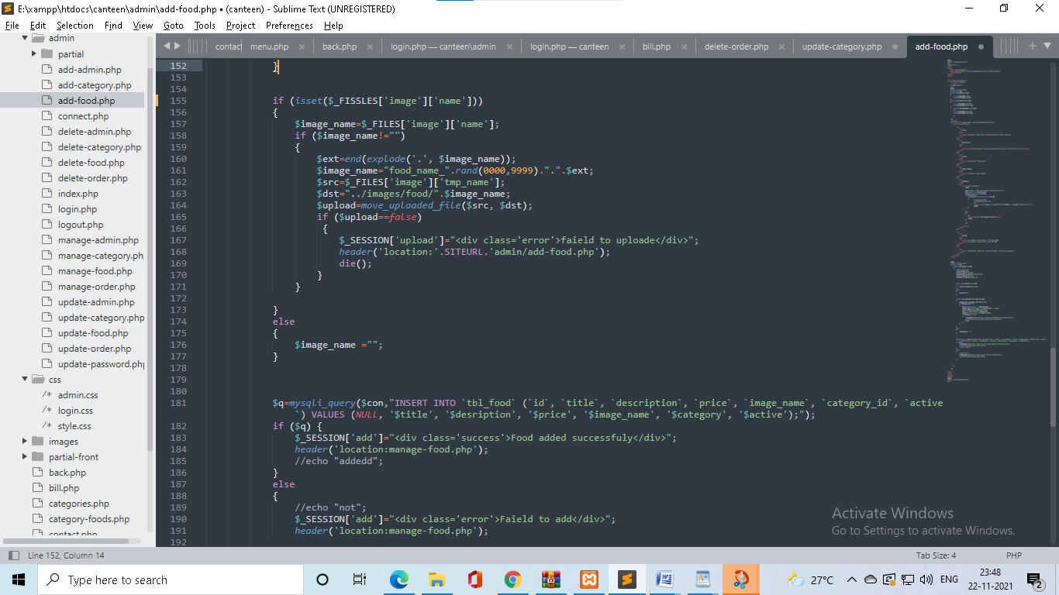

* **Food update page**

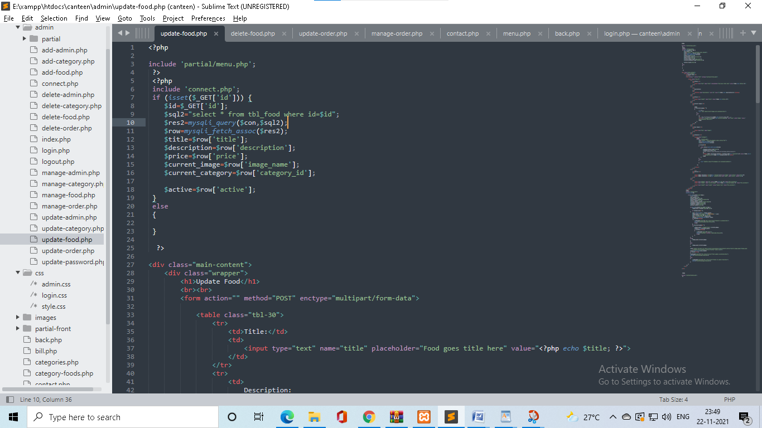

CODEING

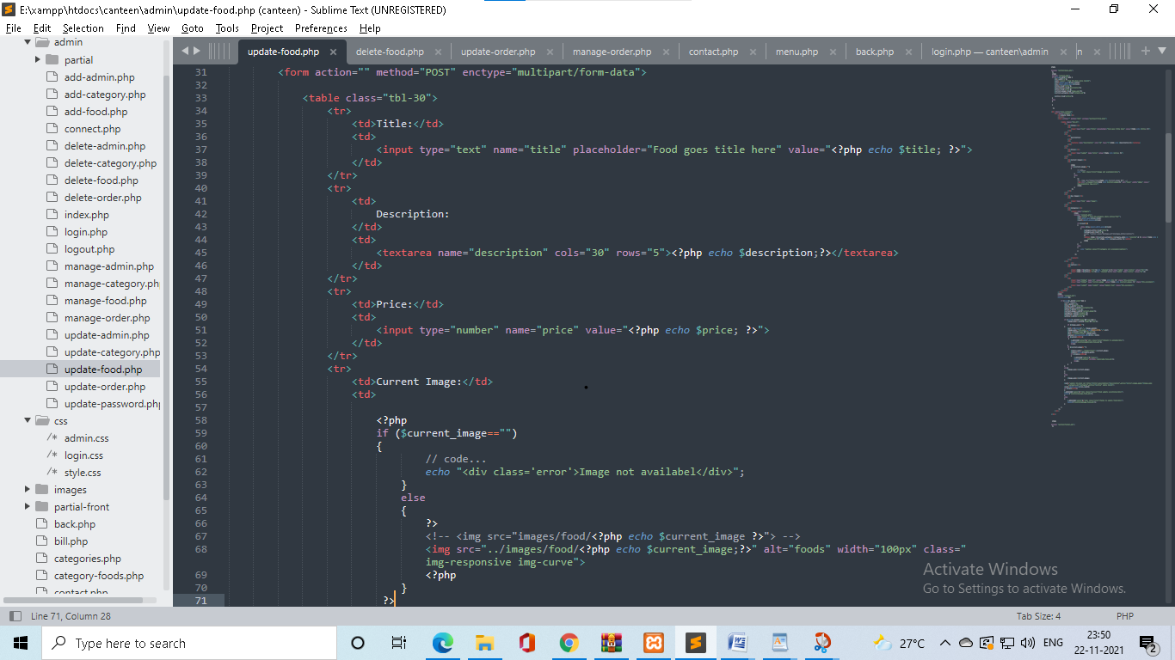

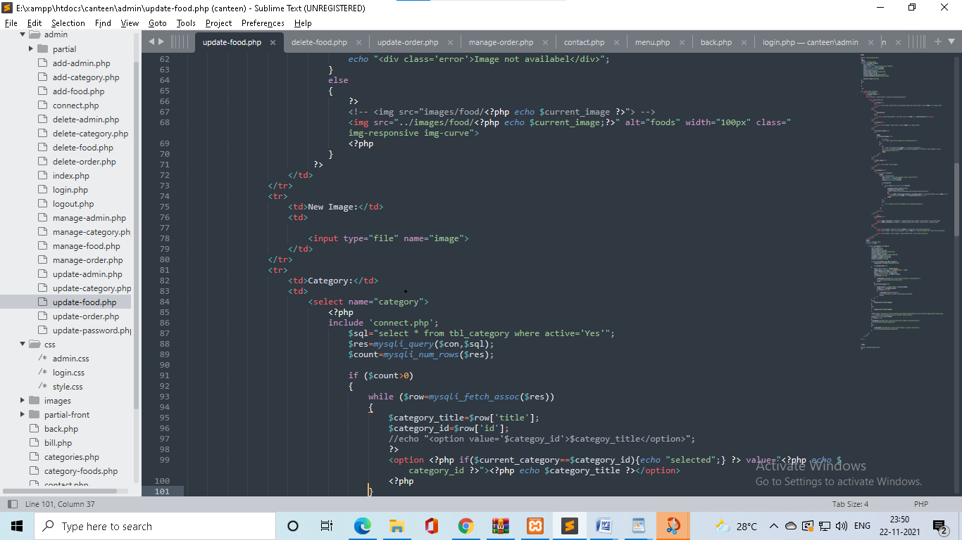

CODEING

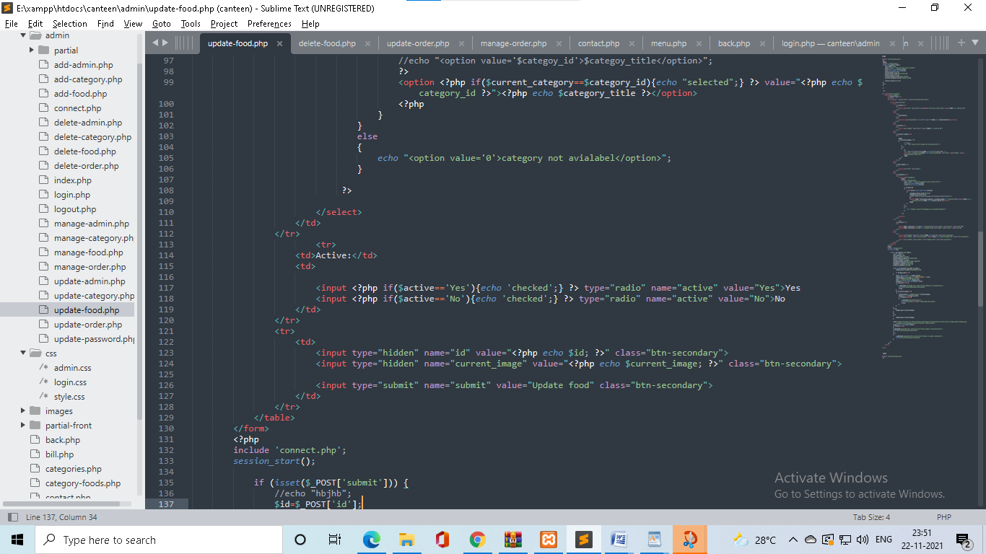

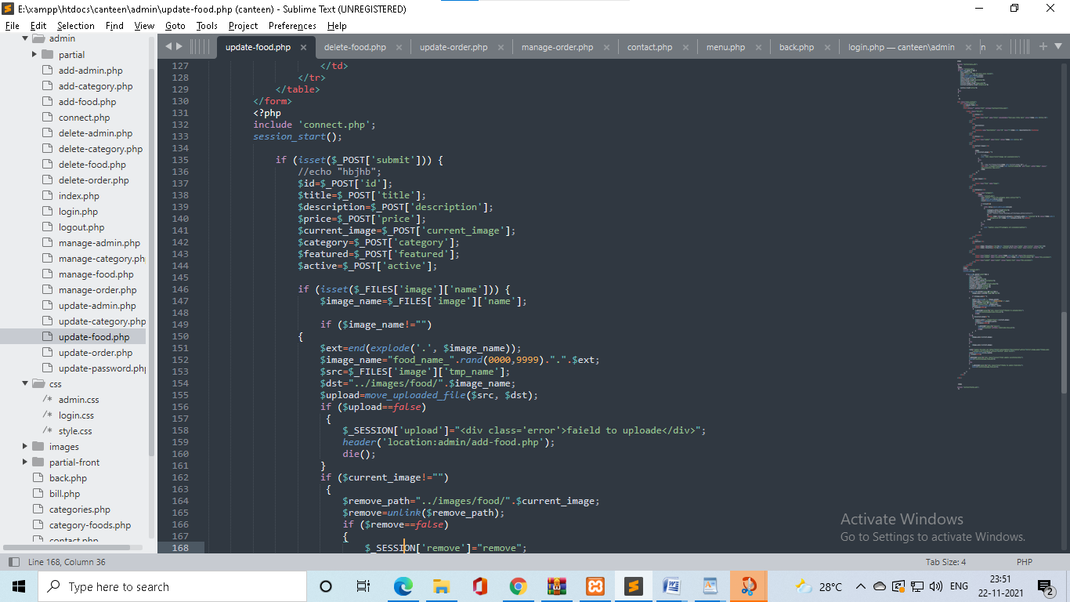

CODEING

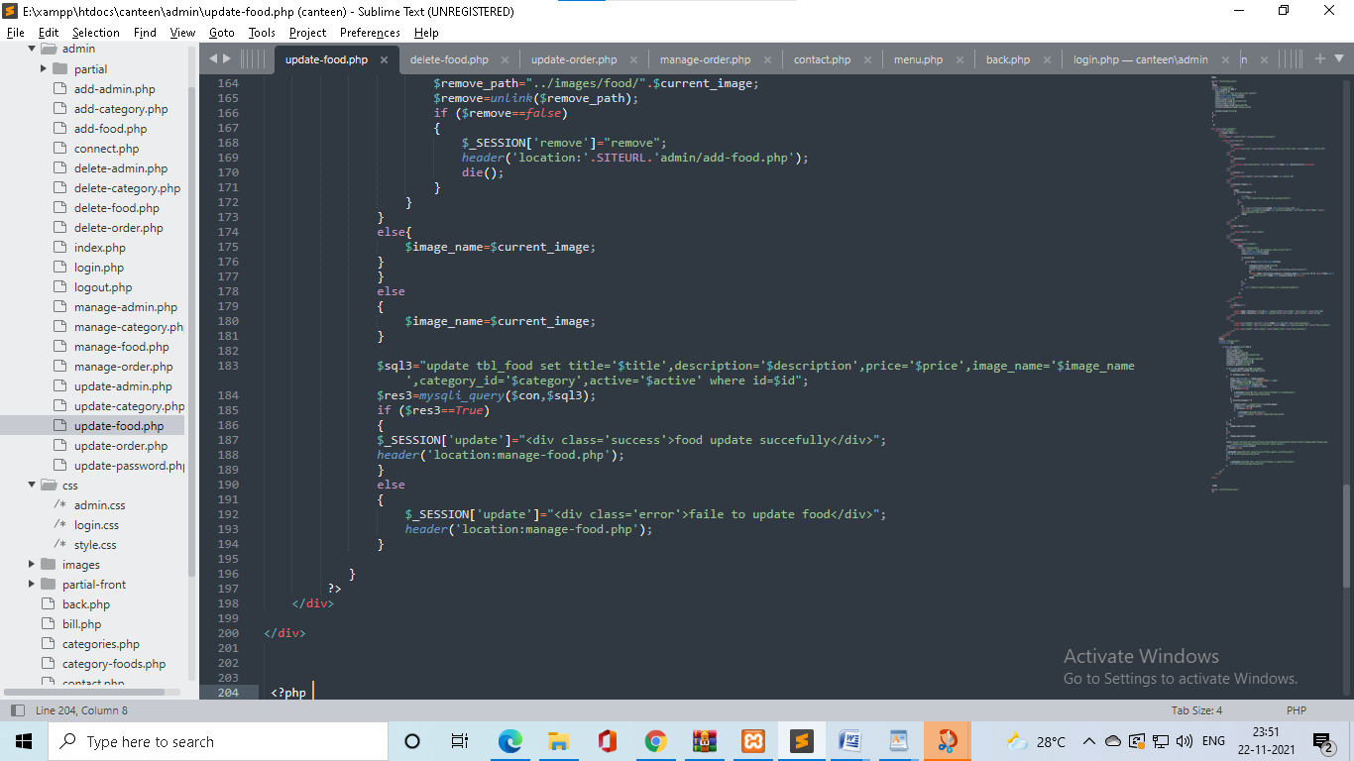

* **Food delete page**

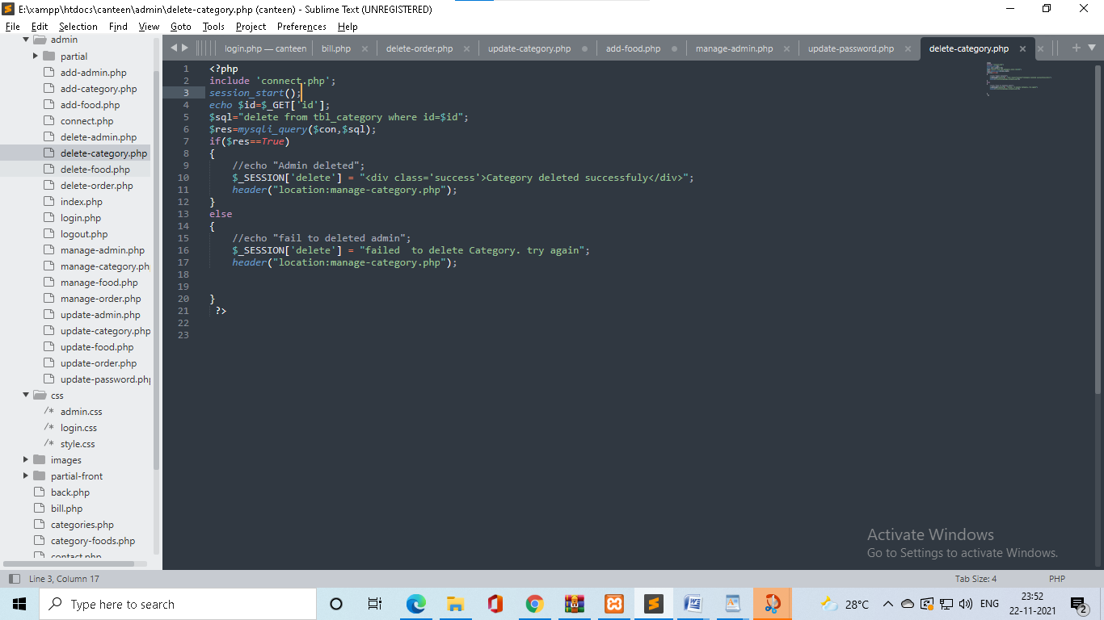

CODEING

* **Manage order page**

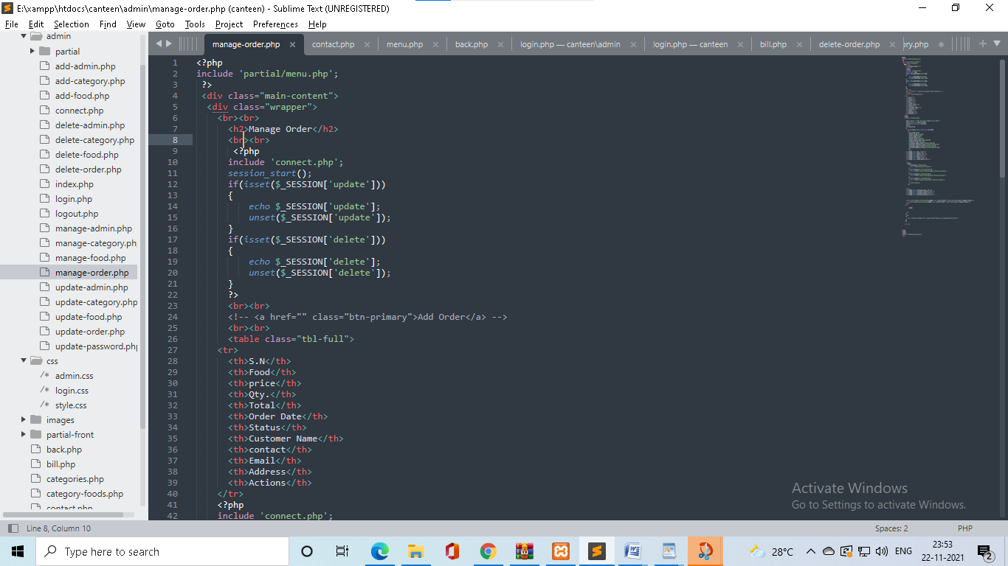

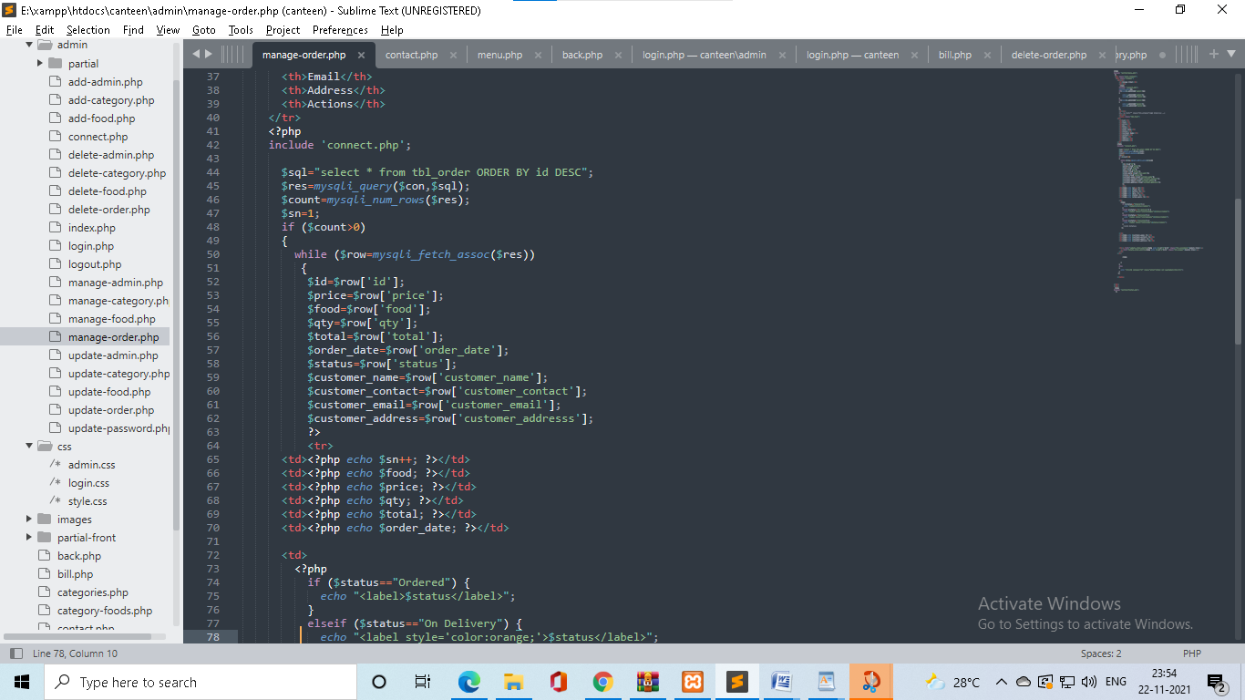

CODEING

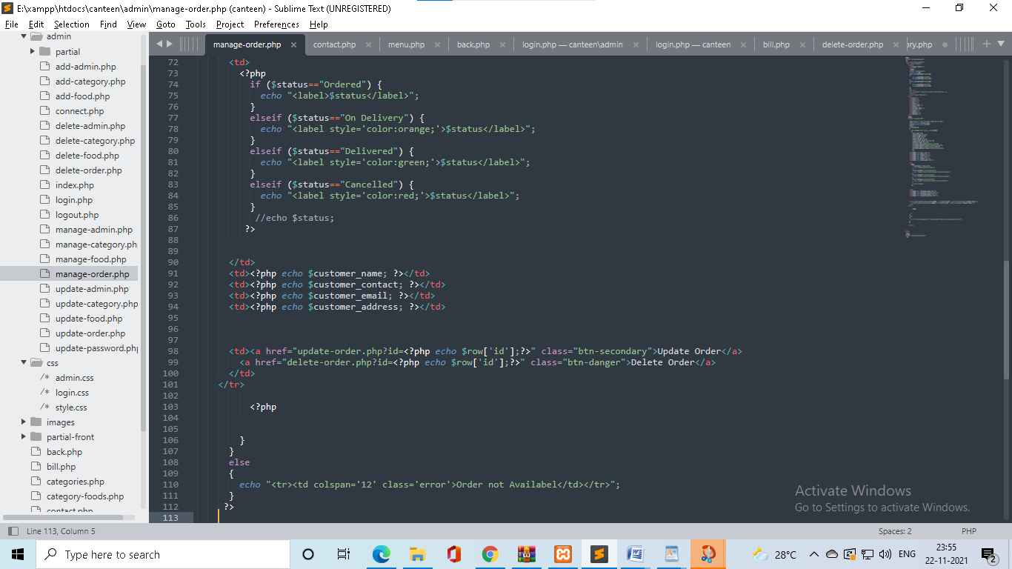

* **Order update page**

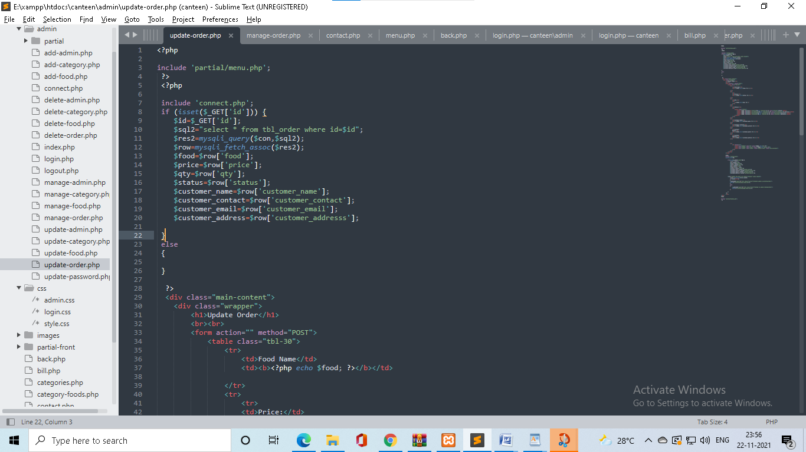

CODEING

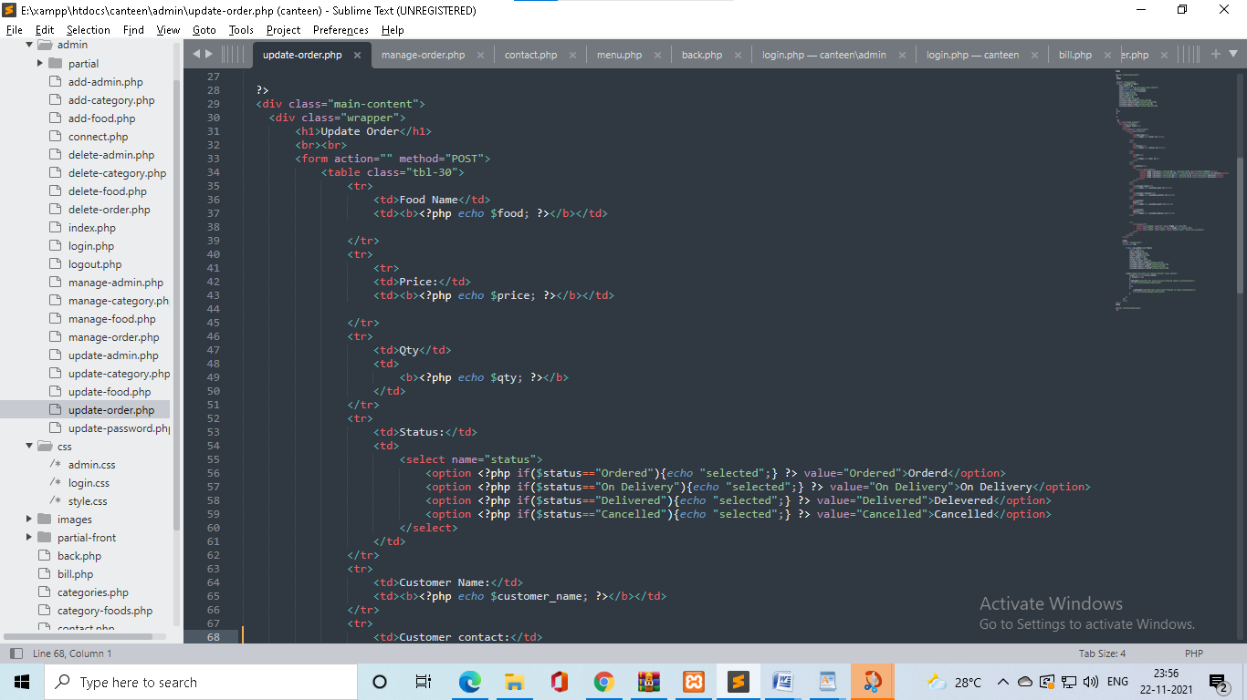

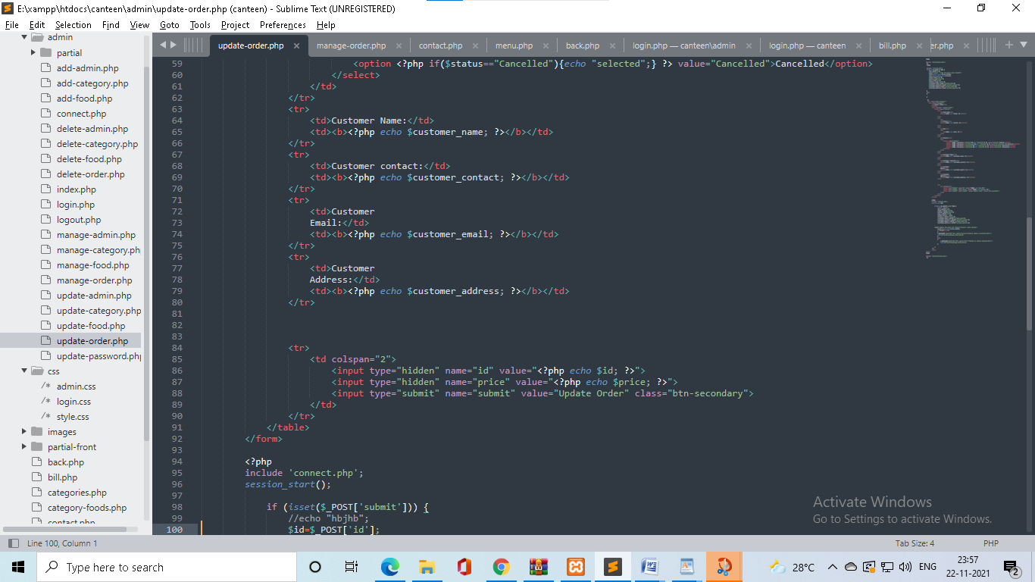

CODEING

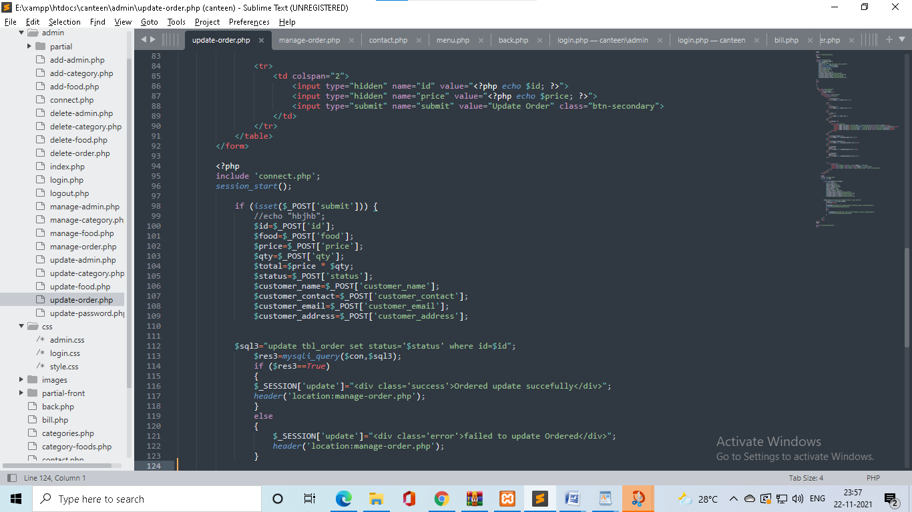

**User side coding**

* **Registration page**

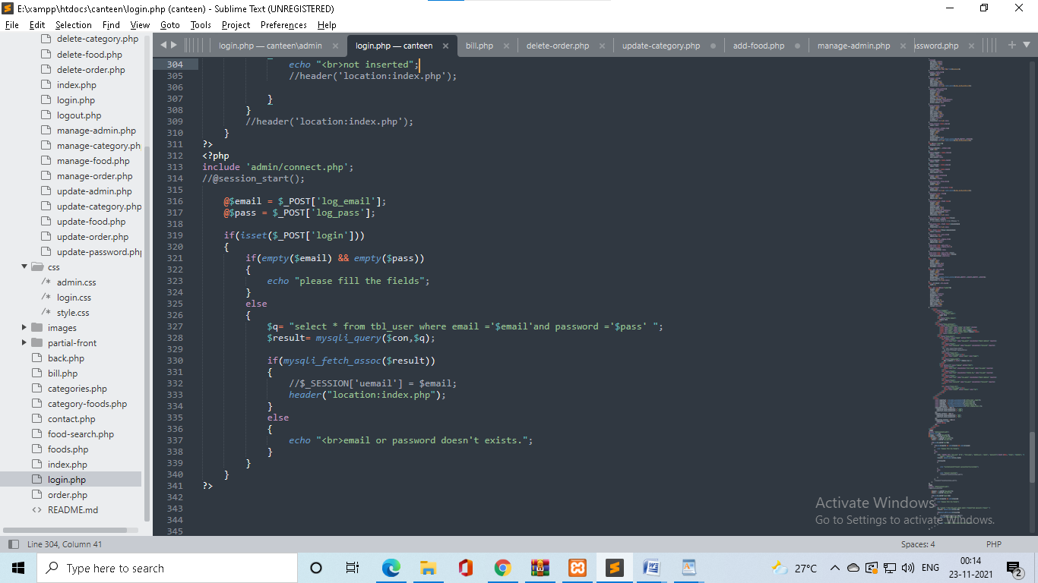

CODEING

* **Index page**

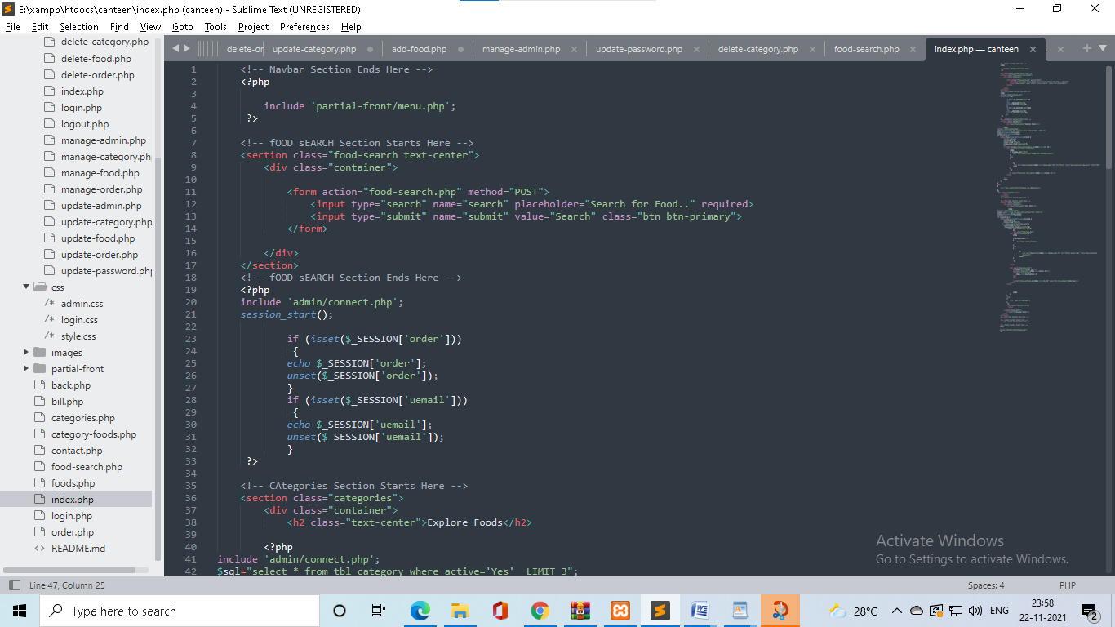

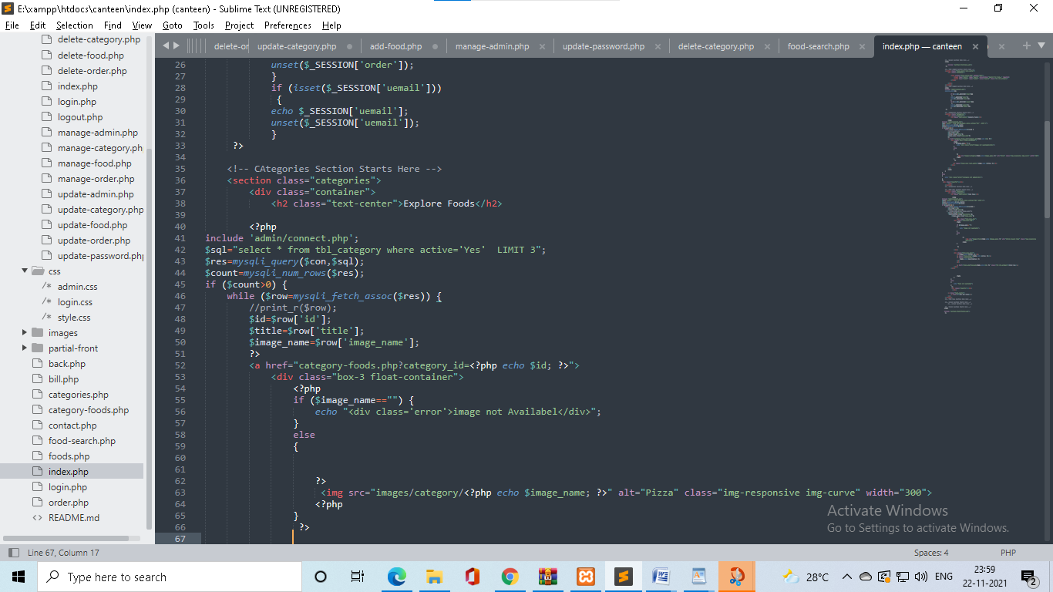

CODEING

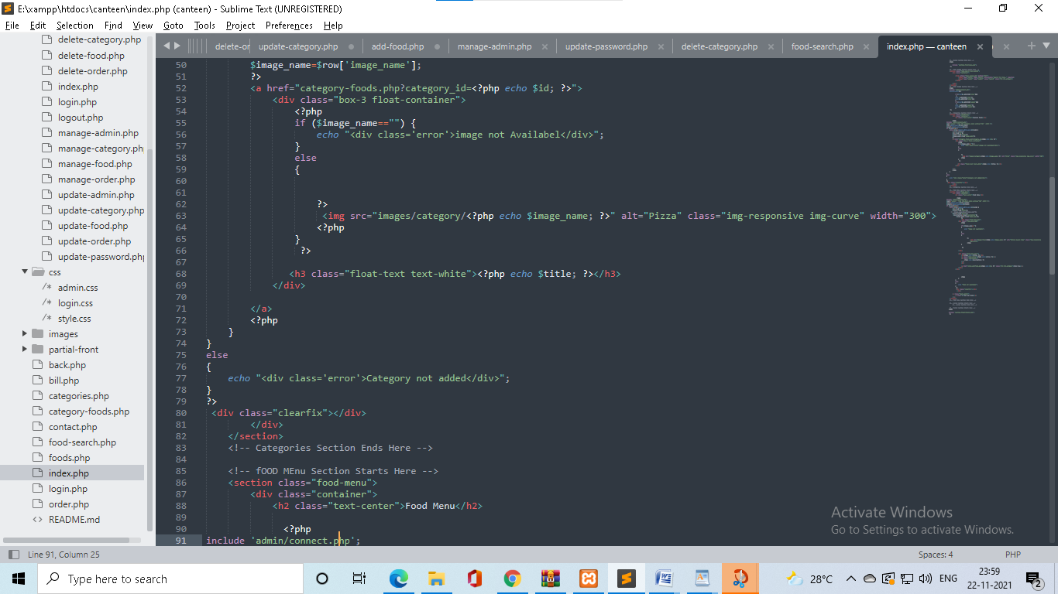

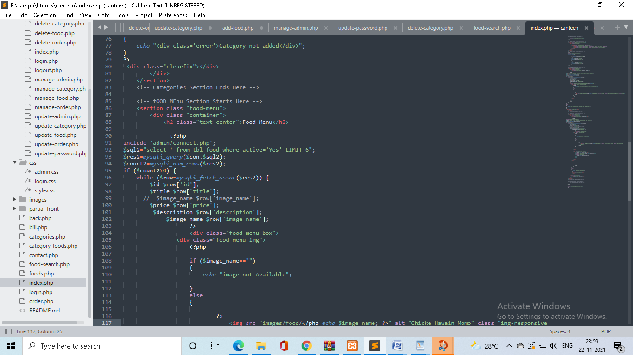

CODEING

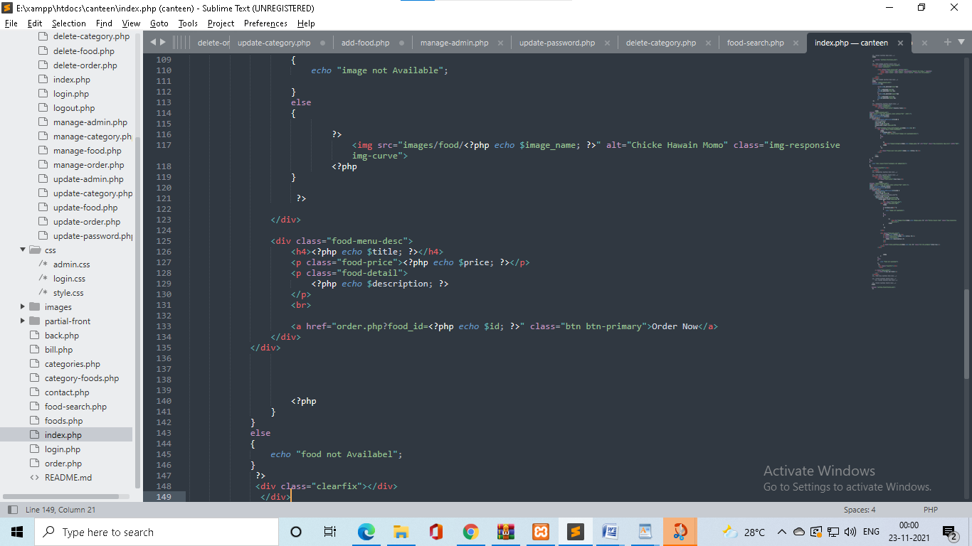

* **categories page**

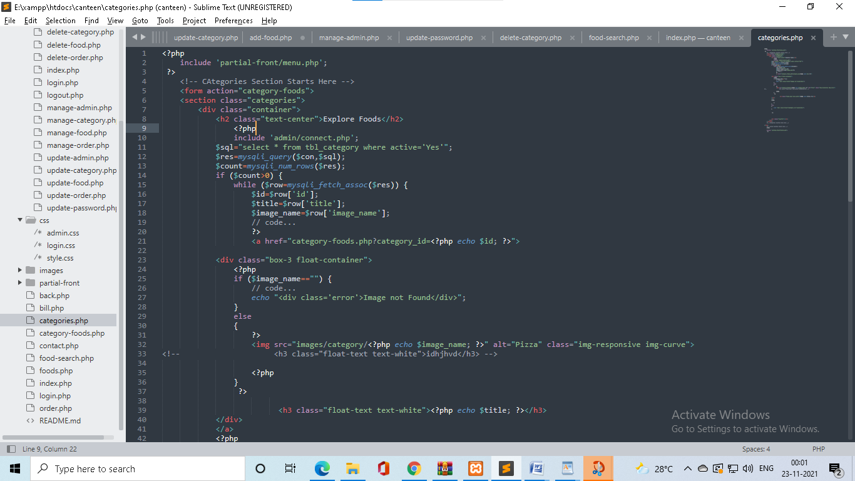

CODEING

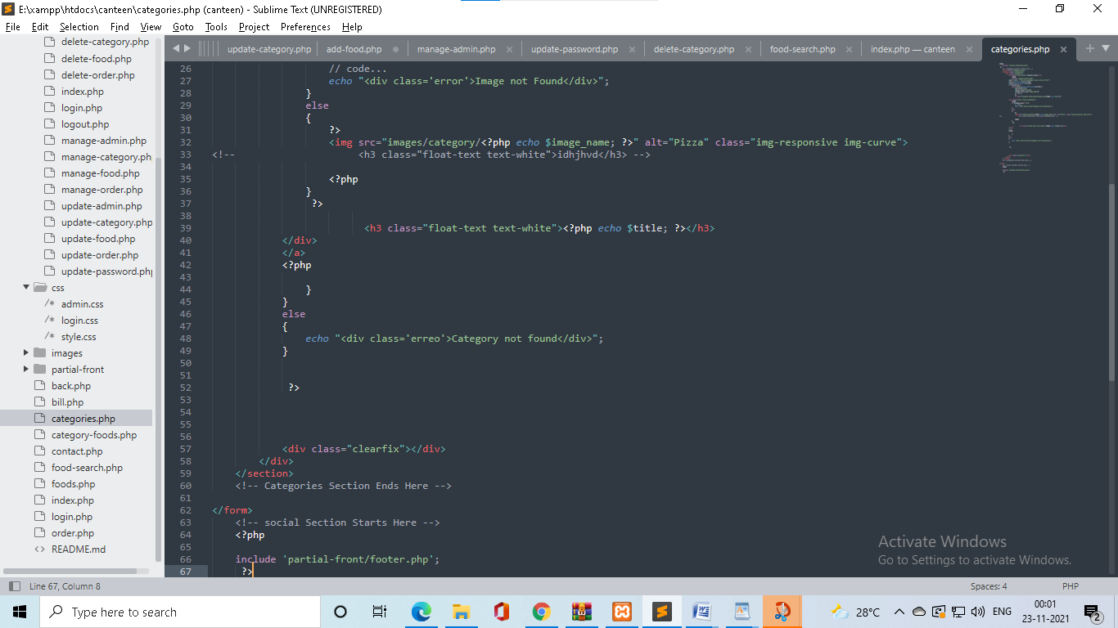

* **category-food page**

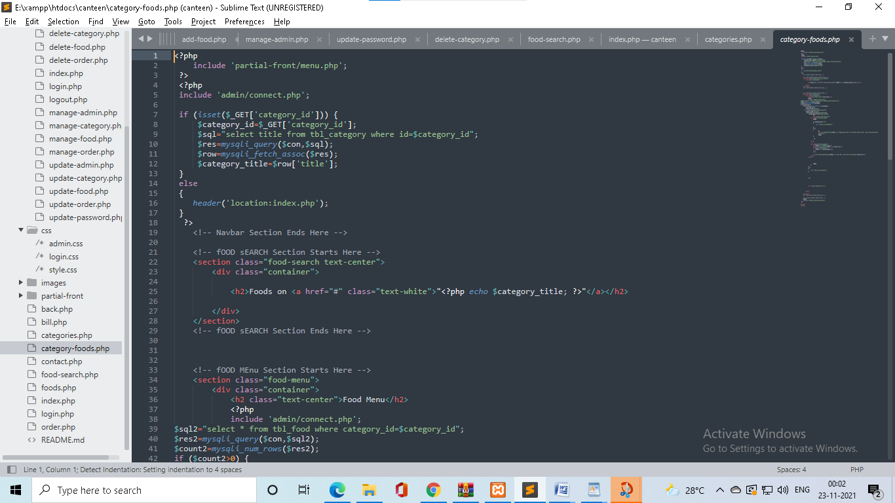

CODEING

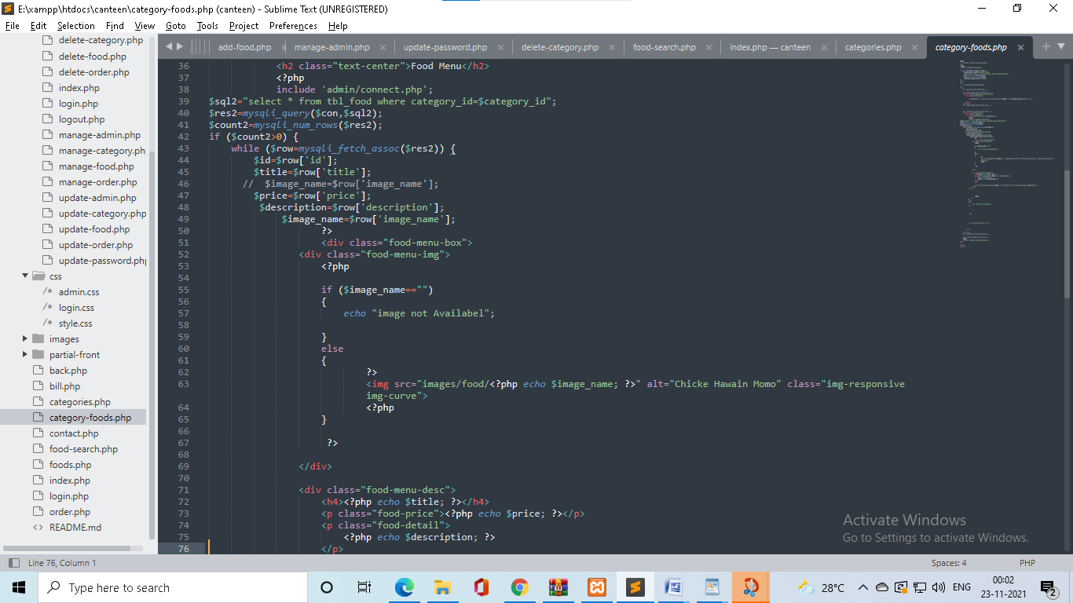

* **category-food page**

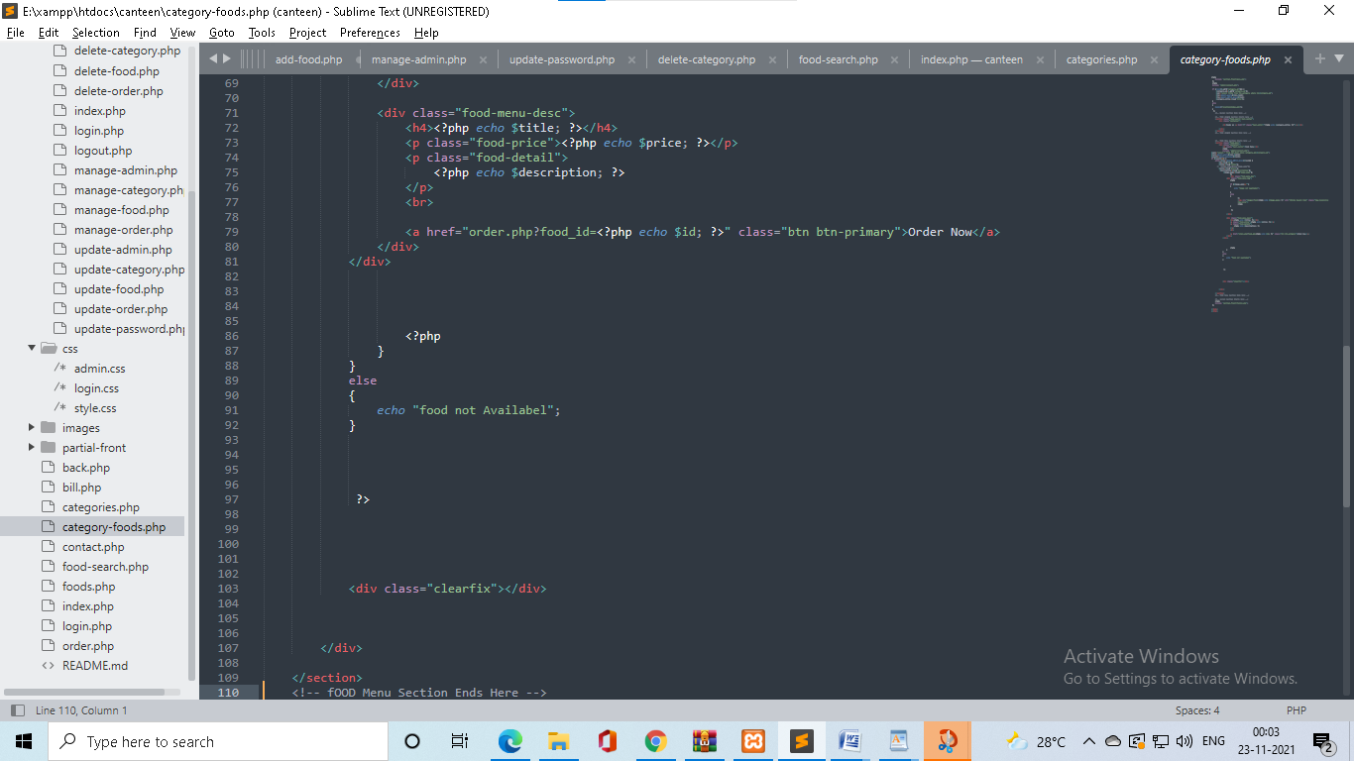

CODEING

* **food page**

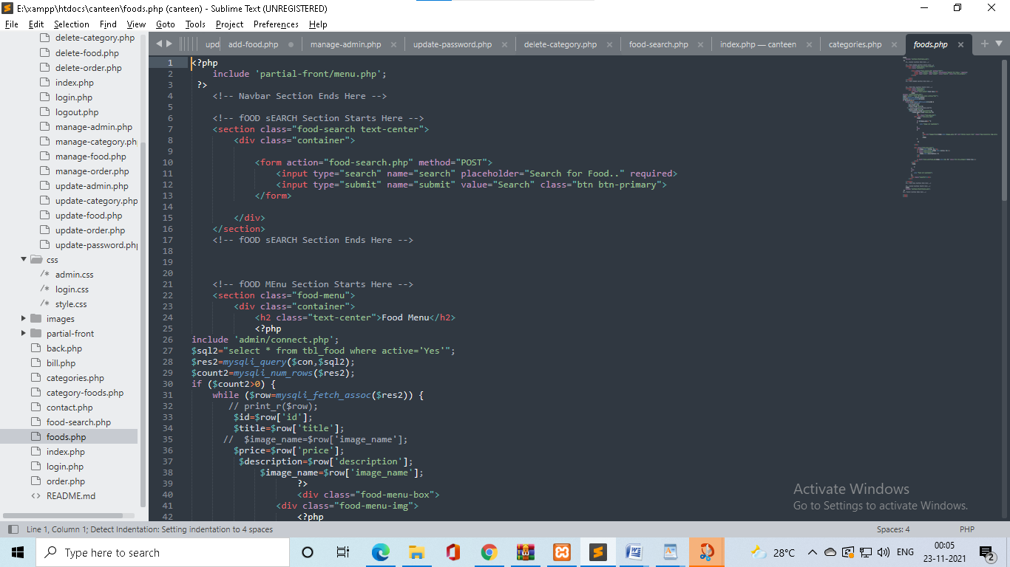

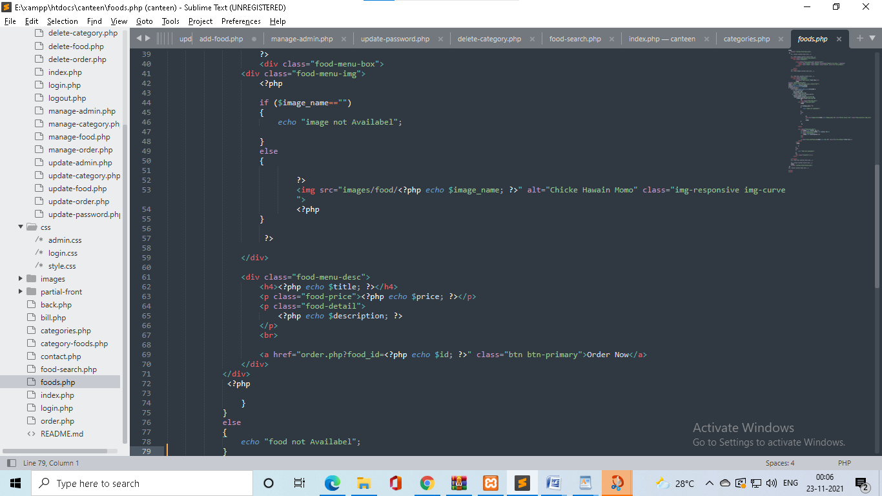

Testing

**6. Testing**

* **Login Page for Admin**

|  |  |  |  |  |  |
| --- | --- | --- | --- | --- | --- |
| **No.** | **Input** | **Description** | **Expected**  **Output** | **Actual output** | **Result** |
| **1** | Empty Username | No input | Error | Error | Login failed |
| **2** | Empty Password | Enter correct password | Error | Error | Login failed |

* **Registration Page for Users**

|  |  |  |  |  |  |
| --- | --- | --- | --- | --- | --- |
| **No.** | **Input** | **Description** | **Expected**  **Output** | **Actual output** | **Result** |
| **1** | id | No input | Error | Error | Registration failed |
| **2** | Full_name | No input | Error | Error | Registration failed |
| **3** | Email | No input | Error | Error | Registration failed |
| **4** | Mobile no | No input | Error | Error | Registration failed |

NEW TOOLS/ TECHNOLOGY LEARNED/ USED

**7. NEW TOOLS/ TECHNOLOGY LEARNED/ USED:**

* Notepad as Editor.
* For backend learned MYSQL With

PHP. Learned MYSQl as Database.

* The **PHP Hypertext Preprocessor (PHP)** is a programming language that allows web developers to create that interacts with databases. PHP is bacically used for developing web based software applications.
* **PHP** started out as a small open source project that evolved as more and more people found out how useful it was.
* For Frontend **HTML,CSS& JAVASCRIPT.**
* Some CSS for page design
* For backend learned MYSQL With

PHP. Learned MYSQl as Database.

System Limitation

**8. SYSTEM LIMITATION / CONSTRAINTS:**

* Only register users can do order food.
* Admin can only login with their username and password it already stored in database.
* User can register with own email id and password mobile no.

Future EnHancement

**9. Future Enhancement & Opportunities:**

* More efficient design and user experience.
* Apply More efficient constratints.
* Add more features like add food photos.
* People can easily track their orders and admin can maintain the customers database and advance the food delivery system.
* Payment system are only cash on delivery.

Bibliography

**10. BIBLIOGRAPHY & REFERENCES:**

**Website**

* [**WWW.google.com**](http://WWW.google.com)
* [**WWW.youtube.com**](http://WWW.youtube.com)
* [**http://www.w3schools.com**](http://www.w3schools.com)